**Southwark Library Database System**

**By Kevin Hyde-Opoku**

**Contents**

Analysis: 3-18

Background and Identification to the Problem………………………………………3

Computerized system…………………………………………………………………………….4

Description of current system………………………………………………………………..5

Identification of prospective user…………………………………………………………..6

Description of computerized system………………………………………………………7

Data volumes………………………………………………………………………………………….8

Identification of user needs and acceptable limitations………………………….10

Interviews……………………………………………………………………………………………….10-11

E-R relationships……………………………………………………………………………………..12

Feasibility……………………………………………………………………………………………….13

Data Dictionary……………………………………………………………………………………….14-15

Objectives for the proposed system………………………………………………………..16

Data Flow diagrams………………………………………………………………………………...17-18

Design: 19-37

Test Plan…………………………………………………………………………………………………19

Modular Design………………………………………………………………………………………20

Data Dictionary………………………………………………………………………………………21-23

Flow Chart………………………………………………………………………………………………24

Definition of record structure………………………………………………………………….25

Validation………………………………………………………………………………………………..26

Hierarchical chart……………………………………………………………………………………27

SQL Queries…………………………………………………………………………………………….28

Identification of storage media……………………………………………………………….29

Pseudocode…………………………………………………………………………………………….30-33

Technical Solution: 39-48

Testing: 50-66

System Maintenance: 67-81

Evaluation: 82-86

User Manual: 87-88

**Problem Definition**

**Background and identification to the problem**

My week long work experience was in a local library, the Blue Anchor in Bermondsey. I have been a member since my primary school years and I am very conversant with the staff. I opted for the Blue Anchor library due to the relaxed atmosphere and the helpful attitude of its staff. The complicated paper-based system and regular queues; drew my attention to their slow and laborious cataloguing system.

The current system in the Blue Anchor library is slow, prone to errors and causes frustration amongst its members. It is a paper-based system meaning that all borrowing, reservations and returns are catalogue manually using rubber stamps with inscribed dates or by hand. Frustrations, accusations and arguments between members and library staff about wrong dates, penalty charges, and late returns caused mistrust between both parties. In the past four months over 20 percent of members either reported been asked for their details due to a missing members card or been illegally over-charged. This resulted in members moving on to another library due to mistrust in both parties.

The current system was manageable when the membership was low, but now that the membership has grown to a few thousands with four categories of membership subscriptions, it has become an excessive burden for the librarians. Furthermore, complaints have been received from some members that they have received a demand for payment which has not been applicable.

The inability to access library website was also an issue amongst its members, since most libraries were using new and updated software to increase the their efficiency.

The frustration of the Blue Anchor library card holders was evident, due to the long queues while members wait to be served. The library management team decided on replacing the out dated paper based cataloguing system.

**Analysis**

A new computerised system should be faster and can access over a million members’ details at a click of a button. It includes a hierarchical structure with the primary key being a membership number that can also be represented in a barcode form. The system should be able to monitor members who have not used the library facilities in at a year. It must be efficient, with less manual mistakes, reduce queues and be accurate with members details. The reliable and fast SQL search engine means fewer queues in the library and less frustrated members. Secondly, it allows the librarians the opportunity to teach young children how to access the large catalogue of library materials online with their free time..

Most members remarked on the online support or the 24 hour help desk ready to help members who have forgotten their password. Furthermore, materials can be picked up by working members on their way home from work. The new computerized system will improve efficiency and make members happy.

The database system should detect any false members’ details by checking it with the local authorities’ database of resident details. Members who have their membership cancelled may be eligible to apply again.

Finally, such a system will provide a stress free environment suitable for the librarians to work.

**Description of the Current System**

The paper-based cataloguing system at the Blue Anchor is sluggish, is arduous and fraught with mistakes. It involves card documented cabinet with members profile details in alphabetical order of their surnames.

The catalogue files contain the members’ profile and their most recent borrowed materials and reservations. It also outlines any charges incurred on late returns. Materials such as books and DVDs are lent out for a fortnight and the return dates are manually stamped on the first page. Secondly, members have to be physically present in the library to access their services which is a problem for working members. The computer based system makes it easy for members to access services online in future. For working people with limited time, queuing at the library can be very annoying, when they could reserve a library material online and pick it up on their way home from work.

Secondly, Blue Anchor’s paper based computer system was used to profile members borrowing habits and to inform them of any new materials received by the library. Members can update their profile online and do not need the librarian to do so. Their unique ID number authenticates their access onto their profile and any changes make their access genuine.

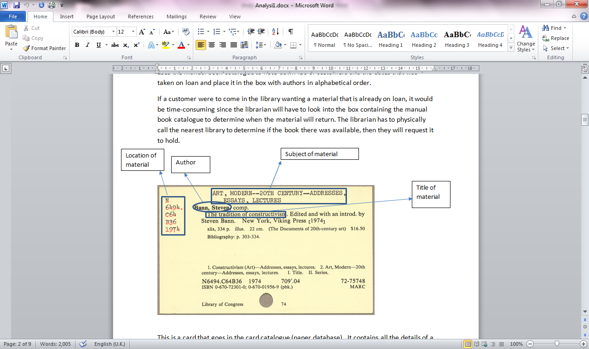

This is a card that goes in the card catalogue (paper-based system). It contains all the details of a material: location, subject, title and author/editor.

**Identification of prospective user**

The librarian can access the computerized format with the username and password whereas its members can access it with their individual ID numbers. The librarians can access members’ details, reservations, late returns and changes incurred and member references. Library members can only access their individual accounts to view their reservations history or reedit their personal profiles.

In the Borough of Southwark, all the libraries under the local authority control have an intranet network which allows individual librarians to keep track of reservations on any books/DVDs in any library. Reservations made of a book or DVD that is in another library can be delivered to the library where the reservation was made. Secondly; the library member may pick up the reserved material in the other library or wait till a borrowed material is returned.

The SQL search language makes it easier for accessing or reserving a material by inputting a few items about the book. Refining or narrowing the search with an author’s name or type of book (i.e. drama, comedy, and thriller).

To be able to access the materials on the computerized system; customers have to apply to become a member of the library. They will be required to present 2 forms of ID; a proof of address and a second relating to their residency in the UK. Residents in Southwark will already be a verified resident on the local authority records; so they will only provide a proof of address ID. On the librarian verifying the presented ID forms, the new member is given an ID card which has an ID number in integers and a barcode. The barcode makes it easier for librarians to swipe the card in a reader to activate the members account details.

In the library premises, members who don’t want to queue may swipe their library card through a barcode reader including a password to access their account details.

In the near future, an upgraded system will allow members to create their own unique password which will make it difficult for anyone to access a members’ account if the ID card is stolen or lost. Members can access their account online; make reservations, settle late return charges and reedit their personal profiles. Most adults use the online services since it allows them to pick up any library materials on their way home from work.

**Description of the computerized system**

The new computer system to be installed at Blue anchor will involve quick access to members’ accounts, electronic activation of members’ accounts using a barcode reader. The return dates of borrowed materials are electronically imprinted on the first page instead of using a dated stamp machine.

Having a back-up store of all database materials on a server from the premises means that nothing is lost in case of any fine/flooding hazards. Members’ library cards have an ID number (integers) with its subsequent barcode.

Members can log onto the computerized system to access their account details using their ID number and their unique registered password. The unique password only known to the member reduces the risk of identity theft and fraudulent actions of stolen library cards. This affords members the privilege of making reservations, setting any late return charges, editing their profiles. Secondly, the local authorities’ networked libraries make it easier for all members to access the huge file materials in any of the librarians at any time. This means; reserved materials do not have to be sent to Blue Anchor to be picked up by members but they in turn can pick up the materials in any library if they cannot wait.

**Data Volumes**

My computerized system stores a maximum of fifteen members’ details, fifteen books, fifteen films and fifteen members’ account details. The library members can borrow, reserve or extend the library materials on any networked system whereas librarians check and update the details related to members and materials.

My system will need a faster processor in order to update details of members’ profiles, reservations, lock in return dates on members’ profiles and materials, as well as speeds up all the various processes in the library. The processor will inform a member that wishes to borrow a material if the material is reserved or have already been borrowed.

### Identification of user needs and acceptable limitations

### Librarians preferred to:

### Store details of members and materials

### Update details of members and materials if necessary

### Store materials that are available and unavailable in the library

### Save the updated details on a file if the user prefers to.

### Easy accesses to members contact details.

### Their borrowing habits and late return charges

### Members preferred to:

### Store details of borrowed/reserved materials

### Store a colour background change for the user.

### Allow members to log on.

### Members can update their profile

### To be able to access library materials online

### Reserve library resources and update details

### 40 percent of library members are employed and this means they can only pick up materials on their way here from work.

### Reduce queues of serving members

### If a member loses their library card, librarians can access their account by asking for their date of birth and their full name.

### My system will not be able to create a library card automatically since it’s too complex for the system and the librarians (user) would prefer to give the library card to the member.

### A barcoded plastic card’s details can be logged on to members profile as their membership number.

### Interviews

I interviewed a 45 year old librarian about how the current system which is paper based works, and about the library in relation to customers.

Interview with the librarian:

Q. How does the current system work?

The system is currently a paper-based system that is prone to mistakes and slow.

Q. What does paper-based system mean?

The paper system works by containing information about library materials and details of residents that are members. Library members have to find their materials from a card catalogue, not an internet database. The materials contain an issue/return card which is then filled out by the librarian and kept in safe keeping for records. The system catalogues members and library materials on rectangular cards and stored in alphabetical order in the cabinet drawers.

Q. What are the disadvantages of using a paper-based system?

It’s slow prone to mistakes and this result in long queues.

Q. What do customers prefer the system to be run on?

Customers prefer the system to be run electronically since it’s quicker to access and very efficient with less queues.

Q. Is there another way for customers to borrow library materials instead of going to

the library?

Customers who are members have to log to the Southwark local library website and login with their username and password in order to reserve.

Q. How is the system running now easier?

It’s quicker compared to paper-based system, and it helps us librarians in terms of dealing with customers at a quicker rate.

Q. Can customers from another borough use a library in Southwark?

No unless, they are registered Southwark library members.

I realised that I need to make my computerized library system more efficient that can help both members and librarians. Putting the library database on the internet is a future development.

**Interviews**

I interviewed a 38 year old customer who regularly comes to the library about the library what he uses the library for.

Interview with a customer:

Q. What do you think of the current system?

It’s slow and not many customers like me like to use it.

Q. What do you normally borrow from the library?

I borrow fiction books and DVDs for my children to watch.

Q. Do you prefer to go to the library to borrow library materials or use the Southwark

library website?

I prefer to use the website since I can see which materials are available without going there in person to check.

Q. What makes the paper-based system slow?

It’s time consuming and makes librarians put in more effort.

Q. Do you have any ideas to improve the current system?

It would be more efficient, convenient and better for the current system to be electronic as it is faster meaning less effort made for the librarians. It’s less time consuming and makes my life a bit easier since I have my family to take care of and I can’t spend all day in the library.

### I realised that my system needs to run faster than the manual system and can save members time.

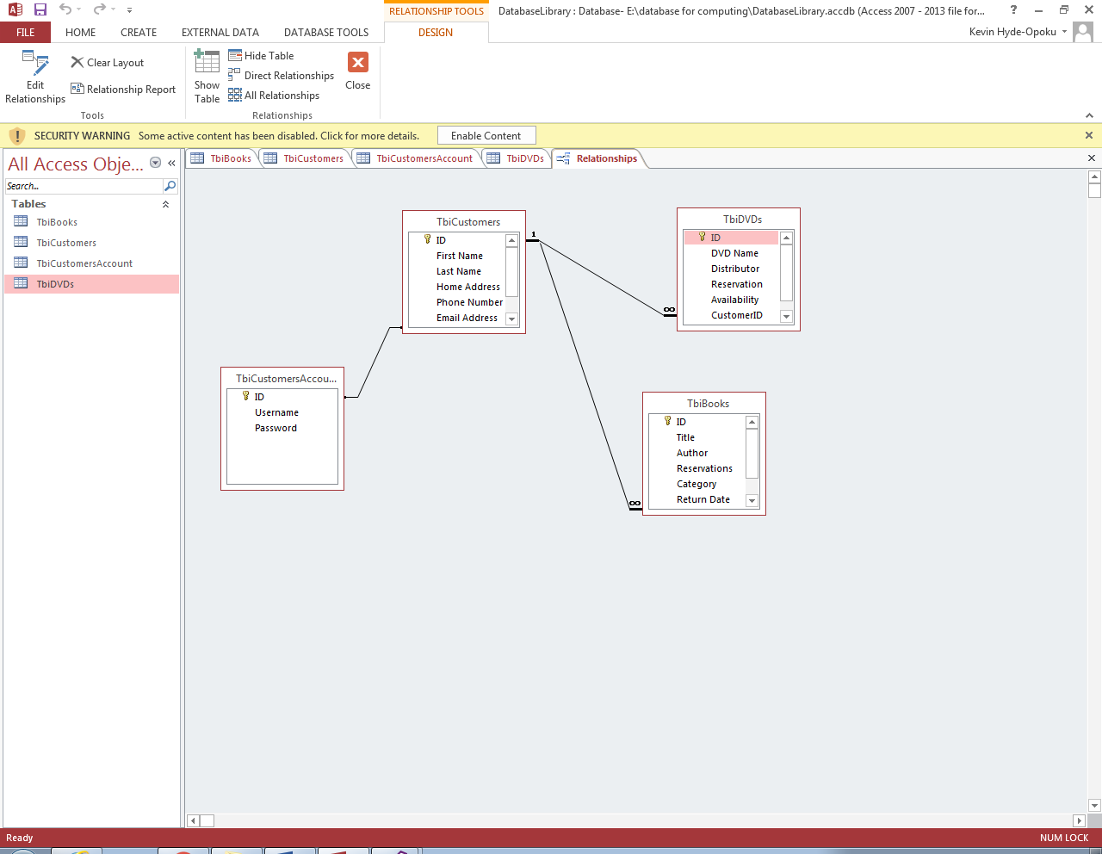**E-R Relationship diagram**

The relationship between the customer table and the customer account table is a one-to-one since each customer can have a customer account. A customer can’t have more than one account since this will not be applicable in a database. It is possible to have the same name and address but the unique membership number or barcoded number. The librarian will find it difficult to determine which account the customer is using or whether their details have changed within the account.

The relationship between the customer table and the DVDs table is one-to-many since a customer can borrow as many DVDs as they want. The user doesn’t have to borrow many DVDs as they have a choice to even borrow one DVDs.

The relationship between the customer table and the books table is one-to-many since a customer can borrow as many books as they want. They don’t have to borrow many books as they also have a choice to even borrow one book.

The membership number is hence a primary key, with the book ID/USBN been a foreign key

**Feasibility**

The current system is slow and fraught with numerous problems. Information is stored on paper in folders or filling cabinets. Since no computers are involved, it makes the librarian’s work extremely difficult. The process involves the librarian manually edit members details, record reservations, enter return dates on library resources as well as cataloguing the library materials in alphabetical format. The librarian’s workload causes frustration amongst members heading attention; queues in the library, losing track of reservation cards etc.

Possible solutions will involve installing a computerized system:

* Interactive/ Wi-Fi which will afford members the privilege of logging onto the network.
* LAN/WAN network depending on the scope of workload and backup storage facilities.
* Peer to peer network / server-band network depending on how many computers are involved in the network.
* Primary and secondary storage facilities as well as speed of download.

The local authority controls all the libraries including the Blue Anchor in Bermondsey. A server based network will benefit the library staff in having backup facilities off-write. This will allow the staff to be able to work in case of a computer crash.

Secondly, an interactive / Wi-Fi network will allow members to be able to log on to their account whilst on site or off site.

**Problems with implementing such a system**

Initially, the proposed system was to ease queues, membership congestion, and speed up processing of demands placed on librarians. The computer systems implementation will focus on hard disk memory capacity and RAMs speed of executing request.

The interactive nature of the computer and the ability of members to log on will be an option depending on cost. Initially, consideration will be given to a stand alone computer.

### Analysis Data Dictionary

|  |  |  |  |  |
| --- | --- | --- | --- | --- |
| Field name | Description | Data type | Field size | Example data |
| BookID | To identify books | Integer | 9 | 5 |
| Title | The name of the book | String | 40 | Bleach |
| Author | The writer of the book | String | 17 | Tite Kubo |
| Reservations | The date the customer has taken material | Date/time | 10 | 16/08/2016 |
| Category | The genre of the book | String | 18 | anime |
| Return Date | The date the book needs to be returned | Date/time | 10 | 12/09/2016 |
| Availability | If the book is available or not | Boolean | 3 | Yes |
| CustomerID | To identify customers | Integer | 9 | 4 |

|  |  |  |  |  |
| --- | --- | --- | --- | --- |
| Field name | Description | Data type | Field size | Example data |
| CustomerID | To identify customers | Integer | 9 | 5 |
| First Name | First name | String | 10 | Raymen |
| Last Name | Surname | String | 13 | Hoang |
| Home Address | Where clients live | String | 46 | 131 Great Suffolk St, London SE1 1PP, UK |
| Phone Number | Members contact detailsFor instance, mobile, work or home number | Integer | 11 | 07335 963933 |
| Email Address | To send notifications or materials customers may be interested in | String | 22 | Rayjai@virginmedia.com |
| Date of Birth | The date customers are born | Date/time | 9 | 14/01/1974 |
| AccountID | To identify customers’ account | Integer | 9 | 5 |

|  |  |  |  |  |
| --- | --- | --- | --- | --- |
| Field name | Description | Data type | Field size | Example data |
| AccountID | To identify customers’ accounts | Integer | 9 | 2 |
| Username | A username that a client prefers to use for identification purposes | String | 7 | Byakuya |
| Password | Private code | String | 13 | badass |

|  |  |  |  |  |
| --- | --- | --- | --- | --- |
| Field name | Description | Data type | Field size | Example data |
| DVDsID | To identify DVDs | Integer | 9 | 5 |
| DVD Name | The title of DVDs | String | 45 | Captain America: Civil War |
| Distributor | The company that creates the film | String | 23 | Paramount / Warner Bros |
| Reservation | The date the customer has taken material | Date/time | 10 | 05/01/2017 |
| Availability | If the material is available or not | Boolean | 3 | Yes |
| CustomerID | To identify Customers | Integer | 9 | 4 |
| Return date | The date the book needs to be returned | Date/time | 10 | 09/02/2017 |

**Objectives for the proposed system**

1. The system should be reliable and more efficient to use.
2. The system should be able to add and delete data with no problems.
3. Should charge members who fail to return the resource on the date given.
4. The system has two main forms of the library and the login system.
5. The system can be saved on a file or on the hard drive.
6. Colour of the background can be changed.
7. Change information on the database if necessary.
8. Add recommendations for members every time they borrow any library resource.

**Data flow diagram for librarian**

Stored in database

Stored in database

Stored in database

Stored in database

4 Search library materials and members info

Add records

1

Add library materials and members info

3 Update library materials and members info

Delete records

Viewed records

Update records

Search

Delete

Add

Login/password

2 Delete library materials and members info

Update

Login

**Data flow diagram for library member**

Check member library material/return

ID number

ID number

Stored in database

Renewal

Stored in database

Library material return

Date due

Availability

ID number

Request library material

View of library material

Register

New customer

Member

Status

Database

**Design**

**Test plan**

The aim of the project is to create a system for librarians that allow them to control the data available on the database system; updating member’s details/list, backlog of library materials and updating library materials. Create a system for members where they can borrow library resources and return them in an efficient way. I will program in visual basic and it will be used by librarians/members from any Southwark Library.

The librarian can edit information on member’s library accounts, films and books. He has the option to save the library database into a file on the flash drive or on the hard drive. The members need to check if the library resource they are looking for is available, before they can reserve or borrow it. Any charges will be added for customers if they fail to return the material by the return date being given.

In order to produce the program, I need to produce a design to make sure it meets all the objectives.

**Customer**

|  |  |  |  |
| --- | --- | --- | --- |
| Inputs | Processes | Storage | Output |
| User details | Material | Database tables:   1. Customer information 2. Library stock | Receive a pop-up to determine whether the material is available for borrowing or not |

**Librarian**

|  |  |  |  |
| --- | --- | --- | --- |
| Inputs | Processes | Storage | Output |
| User details for customers who wish to borrow materials  Enter materials | Materials that have been taken or been returned | Database tables:   1. Customer information 2. Library stock | Send customer an email to remind them the return dates.  Block any extension options |

**Modular Design: Form/Navigation Based**

**.** Log-In System Menu

* + Create user details
  + Enter user details
    - Customer’s Details
      * ID
      * First name
      * Last name
      * Home address
      * Phone number
      * Email address
      * Date of Birth
      * Account ID
    - Book Details
      * ID
      * Title

.. Author

* + - * Reservations
      * Category
      * Return Date
      * Availability
      * Customer ID
    - DVD Details
      * ID
      * DVD Name
      * Distributor
      * Reservation
      * Availability
      * Customer ID
      * Return Date
    - Customer Account Details
      * ID
      * Username
      * Password

**Design Data Dictionary**

|  |  |  |  |  |
| --- | --- | --- | --- | --- |
| Field name | Description | Data type | Field size | Example data |
| CustomerID | To identify customers | Integer | 9 | 5 |
| First Name | First name | String | 10 | Raymen |
| Last Name | Surname | String | 13 | Hoang |
| Home Address | Where clients live | String | 46 | 131 Great Suffolk St, London SE1 1PP, UK |
| Phone Number | Members contact detailsFor instance, mobile, work or home number | Integer | 11 | 07335 963933 |
| Email Address | To send notifications or materials customers may be interested in | String | 22 | Rayjai@virginmedia.com |
| Date of Birth | The date customers are born | Date/time | 9 | 14/01/1974 |
| AccountID | To identify customers’ account | Integer | 9 | 5 |

|  |  |  |  |  |
| --- | --- | --- | --- | --- |
| Field name | Description | Data type | Field size | Example data |
| BookID | To identify books | Integer | 9 | 5 |
| Title | The name of the book | String | 40 | Bleach |
| Author | The writer of the book | String | 17 | Tite Kubo |
| Reservations | The date the customer has taken material | Date/time | 10 | 16/08/2016 |
| Category | The genre of the book | String | 18 | Anime |
| Return Date | The date the book needs to be returned | Date/time | 10 | 12/09/2016 |
| Availability | If the book is available or not | Boolean | 3 | Yes |
| CustomerID | To identify customers | Integer | 9 | 4 |

|  |  |  |  |  |
| --- | --- | --- | --- | --- |
| Field name | Description | Data type | Field size | Example data |
| AccountID | To identify customers’ accounts | Integer | 9 | 2 |
| Username | A username that a client prefers to use for identification purposes | String | 7 | Byakuya |
| Password | Private code | String | 13 | Badass |

|  |  |  |  |  |
| --- | --- | --- | --- | --- |
| Field name | Description | Data type | Field size | Example data |
| DVDsID | To identify DVDs | Integer | 9 | 5 |
| DVD Name | The title of DVDs | String | 45 | Captain America: Civil War |
| Distributor | The company that creates the film | String | 23 | Paramount / Warner Bros |
| Reservation | The date the customer has taken material | Date/time | 10 | 05/01/2017 |
| Availability | If the material is available or not | Boolean | 3 | Yes |
| CustomerID | To identify Customers | Integer | 9 | 4 |
| Return date | The date the book needs to be returned | Date/time | 10 | 09/02/2017 |

|  |  |  |  |  |
| --- | --- | --- | --- | --- |
| Field name | Description | Data type | Field size | Example data |
| Save into file | Saving data into a file | String | Varies | Database |
| Open from file | Opening data from a file | String | Varies | Database |

The data are stored in database tables.

**Flowchart of login system**

Close

Login

Valid input

No

The login system is only used by librarians and not the customers.

**Definition of record structure**

The user has the option to save the library system into a text file. If the user wishes to save the data to a text file, he/she will be shown a folder directory where data will be saved. The user can save the name of the file on an existing folder, or create a new folder to place the saved data.

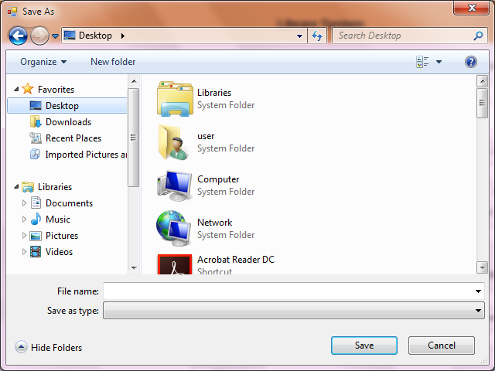

**Validation**

|  |  |  |  |  |
| --- | --- | --- | --- | --- |
| Validation Check | Description | Suitable applicable field | Valid data | Erroneous data |
| Data type | Checks if the data the user inputs is the correct data type | String | admin | 5555 |
| Search for item | Searches for an item the user want | String | Captain America | 13/123 |
| Range | Checks the amount of data that is being inputted | Number of books | Naruto | 2.5 |

|  |  |  |  |  |  |
| --- | --- | --- | --- | --- | --- |
| Field Name | Validation checks | Description | Error Message | Data | Caught |
| First Name | Presence | Make sure the first name is sensible and correct | Inputting first name | Kevin1587438 | No |
| Last Name | Presence | Make sure the last name is sensible and correct | Inputting last name | Sm1th | No |
| DOB | Date | Make sure the date input is sensible and correct | Inputting a valid date | Grey spider | Yes |
| ID | integer | Correct number length for each customer  Max length = 9 | Inputting words, less numbers or more that exceeds the length | 476 | Yes |

**Hierarchical structure**

Library Owner

Members

Library materials

Librarians

Films

Books

Comedy

Action

Fiction

Romance

non-Fiction

**SQL Queries**

SELECT TbiCustomers. [First Name], TbiCustomers. [Last Name], TbiCustomers. [Home Address], TbiCustomers.[Phone Number], TbiCustomers.[Email Address], TbiCustomers.[Date of Birth], TbiCustomers.AccountID, TbiCustomers.ID

FROM TbiCustomers;

Description: This SQL statement selects the details (first name, last name, home address, phone number, email address, date of birth, account ID, customer ID) of a customer selected by the user. The user can view details of a customer if any changes are needed to be made.

SELECT TbiBooks.ID, TbiBooks.Title, TbiBooks.Author, TbiBooks.Reservations, TbiBooks.Category, TbiBooks.Availability, TbiBooks.CustomerID

FROM TbiBooks;

Description: This SQL statement selects the details (book ID, title, author, reservations, category, availability, customer ID) of a book selected by the user. The user can view details of a book if any changes are needed to be made.

SELECT TbiDVDs.ID, TbiDVDs.[DVD Name], TbiDVDs.Distributor, TbiDVDs.Reservation, TbiDVDs.Availability, TbiDVDs.CustomerID, TbiDVDs.[Return date]

FROM TbiDVDs;

Description: This SQL statement selects the details (DVD ID, DVD name, distributor, reservation, availability, customer ID, return date) of a DVD selected by the user. The user can view details of a DVD if any changes are needed to be made.

SELECT TbiCustomersAccount.ID, TbiCustomersAccount.Username, TbiCustomersAccount.Password

FROM TbiCustomersAccount;

Description: This SQL statement selects the details (account ID, username and password) of a customer account selected by the user. The user can view the details of a DVD if any changes are needed to be made.

**Identification of storage media**

The size of my program is 2.87 MB, which was taken from the folder properties. If the user wishes to save the program on the hard drive, it will take up 3.39 MB of space on the disk. The amount of space it takes up when running the program will depend on how much data the user adds, since it is a library system, where customers and numerous library materials are updated and inputted.

The library system will be distributed via an internet connection. This is most suitable since the file size is small which can be downloaded at a fast speed. Also, my data are backed up on the internet and the user will need internet connection to access the system data.

The user can save the details used on the library system into a file so he/she wishes to use the details again.

The system can increase a lot in size overtime, therefore a hard drive would be suitable to handle everything as it will allow the user to read and write information. Moreover, it is secured and reliable since the hard drive has a larger storage capacity and can be stored on a server.

**Pseudocode**

**Login System**

If username= “admin” and password = “qwerty” then

User logged in

Else if username=”” and password = “” then

Output User cannot log in, try again

Else

Output User cannot log in, try again

End If

**Library system**

Function add customers

Output (Add maximum 10 customers)

Output (customer)

End Function

Function add customer account

Output (Add maximum 10 customer account)

Output (customer account)

End Function

Function add films

Output (Add maximum 10 films)

Output (films)

End Function

Function add books

Output (Add maximum 10 books)

Output (books)

End Function

Procedure save details

Output (saved details)

End procedure

Function delete customer

Output (“Do you want to delete the selected user”)

IDTextBox.Text = ""

First_NameTextBox.Text = ""

Last_NameTextBox.Text = ""

Home_AddressTextBox.Text = ""

Phone_NumberTextBox.Text = ""

Email_AddressTextBox.Text = ""

AccountIDTextBox.Text = ""

ComboBox1.Text = ""

End Function

Function: delete customer account

Output (“Do you want to delete the selected user account”)

IDTextBox2.Text = ""

UsernameTextBox.Text = ""

PasswordTextBox.Text = ""

ComboBox3.Text = ""

End Function

Function: delete DVDs

IDTextBox3.Text = ""

DVD_NameTextBox.Text = ""

DistributorTextBox.Text = ""

CustomerIDTextBox1.Text = ""

ComboBox4.Text = ""

End Function

Procedure: delete books

IDTextBox1.Text = ""

TitleTextBox.Text = ""

AuthorTextBox.Text = ""

CategoryTextBox.Text = ""

CustomerIDTextBox.Text = ""

ComboBox2.Text = ""

End Procedure

Procedure sign out

Output (“Do you want to sign out”)

If result = true then

Sign out=true

Else

Sign out=false

End Procedure

Function background colour

If change colour background = true then

Background colour = change colour background

End If

End Function

Function change font colour

IDTextBox.ForeColor = ColorBackground.Color

First_NameTextBox.ForeColor = ColorBackground.Color

Last_NameTextBox.ForeColor = ColorBackground.Color

Home_AddressTextBox.ForeColor = ColorBackground.Color

Phone_NumberTextBox.ForeColor = ColorBackground.Color

Email_AddressTextBox.ForeColor = ColorBackground.Color

Date_of_BirthDateTimePicker.ForeColor = ColorBackground.Color

AccountIDTextBox.ForeColor = ColorBackground.Color

ComboBox1.ForeColor = ColorBackground.Color

IDTextBox1.ForeColor = ColorBackground.Color

TitleTextBox.ForeColor = ColorBackground.Color

AuthorTextBox.ForeColor = ColorBackground.Color

ReservationsDateTimePicker.ForeColor = ColorBackground.Color

CategoryTextBox.ForeColor = ColorBackground.Color

Return_DateDateTimePicker.ForeColor = ColorBackground.Color

CustomerIDTextBox.ForeColor = ColorBackground.Color

ComboBox2.ForeColor = ColorBackground.Color

IDTextBox2.ForeColor = ColorBackground.Color

UsernameTextBox.ForeColor = ColorBackground.Color

PasswordTextBox.ForeColor = ColorBackground.Color

ComboBox3.ForeColor = ColorBackground.Color

IDTextBox3.ForeColor = ColorBackground.Color

DVD_NameTextBox.ForeColor = ColorBackground.Color

DistributorTextBox.ForeColor = ColorBackground.Color

ReservationDateTimePicker.ForeColor = ColorBackground.Color

CustomerIDTextBox1.ForeColor = ColorBackground.Color

Return_dateDateTimePicker1.ForeColor = ColorBackground.Color

ComboBox4.ForeColor = ColorBackground.Color

End Function

Procedure: save into file

FileWriter = New Streamwriter

Results= dialog.result

Results = SaveFileDialog1.ShowDialog

If Results = true then

FileWriter = New Streamwriter (save file. File name)

Close FileWriter

End if

End Procedure

Procedure open file

FileReader = New StreamReader

Results = dialog.result

Results = OpenFileDialog1.ShowDialog

If results = true then

FileReader = New StreamReader = (open file. File name)

Close FileReader

End if

End procedure

Function time

Time. Text= time of the day

End Function

**Explaining login system**

This text box is used for the librarian to enter a username. Also, every username is stored in my program’s system, thus when a username is created it can be used by the librarian to access all of the user’s data that is needed.

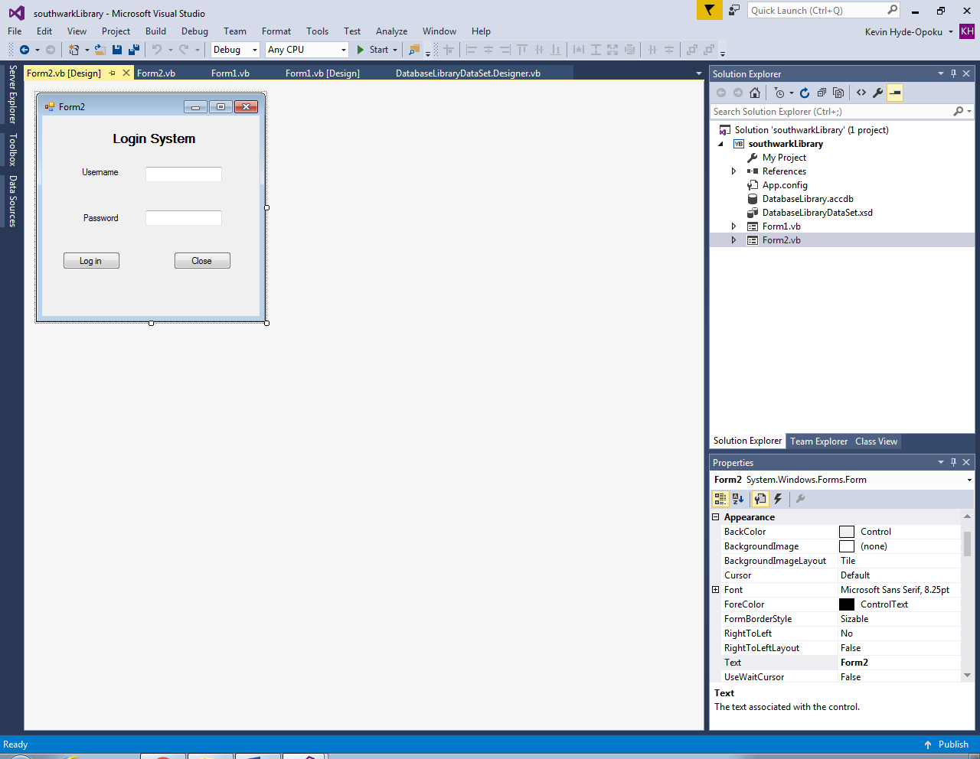

This textbox allows the librarian to enter the password. Upon entering the password, the characters of the letters are replaced by an asterisk ( * ). This is used to hide the password to prevent any unauthorised access. If the password is correctly matched with the username my system will allow the user to log in.

If the username and password are correct, when the user clicks the log in button, the process will be successful and the librarian will be able to access the library system. Conversely if either the username or password is incorrect, an error will be shown.

Once the user clicks the close button, the system will stop.

**Explaining the form of the library system**

This is the title of the system and it will always be shown in a professional way at the top of the system

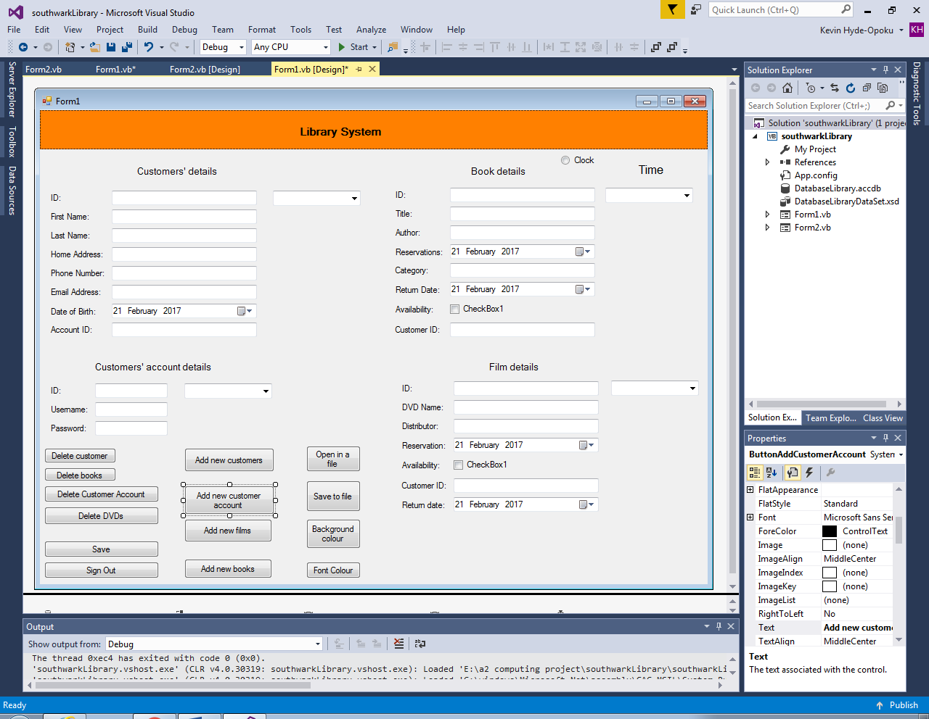

This segment highlights details of books that are ready to borrow or unavailable at their time of request.

This section contains details of customers that are members of the library.

It contains details of accounts for each customer.

This fragment illustrates information of films that are available and unavailable in the library at their time of request.

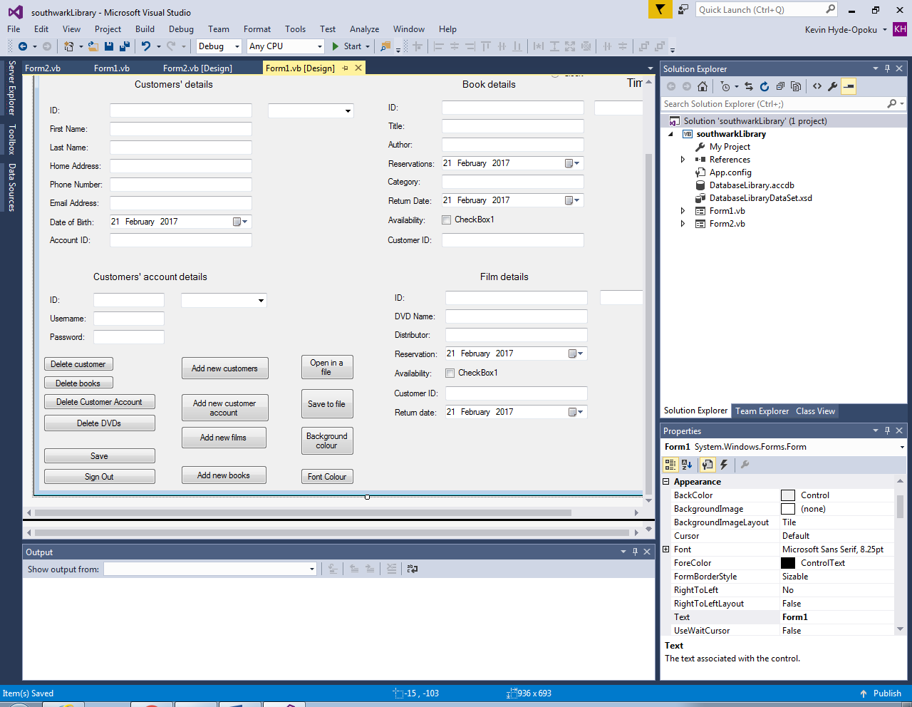

The user can save the data to a file and can open this library system in the file that was saved previously.

The user has a choice to change the colour of the background or the font colour

This section covers the choice for the user to add new data

This section contains the options for the user to delete information related to customers, books, films and accounts.

This part provides the option for the administrator (user/librarian) to save the information that has been changed or sign out.

**Data security and integrity**

To open the library system, the user (librarians) will need the correct login details. This security measure is necessary to prevent unauthorised access to member’s details, identity theft and borrowing history. Only the librarians are able to write or edit data and this will ensure validity, and the security of information. I have restricted access to librarians since information can be fraudulently input by unauthorised persons. Since the library is part of a network, it is easily accessible on the internet. This will afford members the privilege of accessing library materials online. There has only been one login detail created and another one cannot be made therefore the librarian with the most authority can delegate power to the librarians below him/her by distributing the login details. The data that will be inputted in my system is sensitive and personal consequently information needs to be protected by making the system harder to access.

In addition, the password characters are stored as a ‘*’ to prevent any unauthorised access to maliciously change data. This could be done by someone seeing the system users’ password.

I have used validation checks where it is necessary to ensure the integrity of my data. The validation checks are used in areas where the librarians should not enter incorrect information. The first name and last name of a member shouldn’t contain any integers and there should always be a presence when creating a member, thus such validation check is used. In addition mistakes can be made easily when entering/copying a large sum of details so I have restricted the entries for the date of birth and other similar numerical inputs to only integers or the correct formats with words. The system also contain validation checks for books and films since it has to contain the correct ID number and range for the items to exist. The validation checks are crucial as the librarians need to keep track of the library resources and the library users’ data to operate a successful library.

**System Security**

Currently I don’t have any system security since the program and the rest of the system can only be accessed by librarians. The risk of an unauthorised user making changes to the system is minimal as they don’t have access to the system.

It is important for my program to be kept secure as a change in the coding could cause major internal issues without a quick solution, due to the fact that the coding is sensitive to changes and difficult to rectify. Consequently, I am the only one with the authority and the power to amend or make changes to the code as I only have access to it. In the worst scenario, if my system were to be deleted on the hard drive, I have a backup copy of it on my flash drive.

**Text File**

My system contains a text file where the librarian has the option (as data is usually saved on the hard drive) to save the system into a text file or open the system that has been previously saved into a text file. The text file will be easy for the librarian to check the details of members and library resources.

**Technical solution**

This is a dry run testing

|  |  |  |  |  |  |
| --- | --- | --- | --- | --- | --- |
| Test Number | Test Description | Test Data | Typical Erroneous Boundary | Expected Outcome | Outcome |
| 1  Login | It confirms whether the login details are correct. | Username : “ “  Password : “ “ | Field is null  Nothing is being entered | User cannot access the library system | Pass |
| 2  Close | To close the login system. | Click close | The user can accidently close the system as it’s located close to the login button. | The login system will close. | Pass |
| 3  Delete customer | Deleting an existing customer if necessary when no longer using the library. | Click delete customer | Unintentionally deleting a member that uses the library regularly.  Members that have the same first and last name might be incorrectly removed from the system. | Deleted from the database | The customer details are no longer accessible in the system.  Pass |
| 4  Delete customer account | User can delete an existing customer account | Click delete customer account | The record doesn’t exist | Deleted from the database | Customer account details are no longer accessible  Pass |
| 5  Delete books | User can delete available books in the library | Click delete books | Record doesn’t exist | Deleted from the database | Book details no longer accessible  Pass |
| 6  Delete films | User can delete available films in the library | Click delete films | Record doesn’t exist | Deleted from the database | Film details no longer accessible  Pass |
| 7  Add customers | User can add new customers | Click add customers | Field is null | Added to the database | Details now accessible  Fail |
| 8  Add customer account | User can add new customer accounts | Click add new customer account | Field is null | Added to the database | Details now accessible  Fail |
| 9  Add new films | User can add new films | Click add new films | Field is null | Added to the database | Details now accessible  Fail |
| 10  Add new books | User can add new books | Click add new books | Field is null | Added to the database | Details now accessible  Fail |
| 11  Open file | User can open the database | Click open a file | The database wasn’t saved before  Database saved to the wrong file | Open the file and is loaded | Can access the database that has been  Pass |
| 12  Save into file | User can save the database into a file | Click save into a file | Field is null  Wrong save button is clicked | The database is saved into a file | Saved and cannot be lost.  Pass |
| 13  Background colour | User can choose a background colour | Click background colour | User can choose the wrong background colour | Colour change on background from the original to the user choice | Pass |
| 14  Font colour | User can choose a font colour | Click font colour | User can choose the wrong font colour | Colour change on font from the original to the user choice | Fail |
| 15  Save | User can save the database | Click save | User can accidently click save into file | Information on the database are saved | Pass |
| 16  Sign out | User can sign out of the database | Click sign out | User can sign out without saving any information being used | User leaves the library system | Pass |
| 17  Date | User can set dates for library resources that are taken and when it’d due | 21 February 2017 | User can set the wrong return date or date that library material is taken | The dates are set | Pass |
| 18  Availability | The user determines whether the library resources are available in the library | “/” | Set the availability to the wrong library resources | Availability is set | Pass |

**Login System**

Public Class Form2

1

Private Sub Button1_Click(sender As Object, e As EventArgs) Handles Button1.Click

If TextBoxUsername.Text = "admin" And TextBoxPassword.Text = "qwerty" Then

MsgBox("Logged in")

Form1.Show()

'the library system form will show after the user logs in.

ElseIf TextBoxUsername.Text = "" And TextBoxPassword.Text = "" Then

2

MsgBox("Nothing is being entered, try again")

'user failing to enter anything to prevent him/her from being logged in

Else

MsgBox("Wrong username or password, TRY AGAIN!")

'user failing to log in

End If

End Sub

Private Sub Button2_Click(sender As Object, e As EventArgs) Handles Button2.Click

Me.Close()

3

'the form closes after the user finishes using it

'the user can't go back to form 1 now

End Sub

End Class

1. Whenever the login button is clicked, the username and the password must match the default login username and password. If the username and password matches the original login details, the library system will be shown automatically on the user interface.
2. Entering no username and password will restrict the user from accessing the library system; an error message is shown. This also applies to not entering the correct username and password.
3. Once the user has clicked on the close button, They can no longer access the library system or return back to the login system.



**Library System**

Imports System.IO

Public Class Form1

Private Sub TbiBooksBindingNavigatorSaveItem_Click(sender As Object, e As EventArgs)

Me.Validate()

Me.TbiBooksBindingSource.EndEdit()

Me.TableAdapterManager.UpdateAll(Me.DatabaseLibraryDataSet)

End Sub

Private Sub Form1_Load(sender As Object, e As EventArgs) Handles MyBase.Load

'TODO: This line of code loads data into the 'DatabaseLibraryDataSet.TbiDVDs' table. You can move, or remove it, as needed.

Me.TbiDVDsTableAdapter.Fill(Me.DatabaseLibraryDataSet.TbiDVDs)

'TODO: This line of code loads data into the 'DatabaseLibraryDataSet.TbiCustomersAccount' table. You can move, or remove it, as needed.

Me.TbiCustomersAccountTableAdapter.Fill(Me.DatabaseLibraryDataSet.TbiCustomersAccount)

'TODO: This line of code loads data into the 'DatabaseLibraryDataSet.TbiCustomers' table. You can move, or remove it, as needed.

Me.TbiCustomersTableAdapter.Fill(Me.DatabaseLibraryDataSet.TbiCustomers)

'TODO: This line of code loads data into the 'DatabaseLibraryDataSet.TbiBooks' table. You can move, or remove it, as needed.

Me.TbiBooksTableAdapter.Fill(Me.DatabaseLibraryDataSet.TbiBooks)

ComboBox1.Visible = True

ComboBox2.Visible = True

ComboBox3.Visible = True

ComboBox4.Visible = True

RadioButton1.Checked = True

End Sub

Private Sub ButtonAddCustomers_Click(sender As Object, e As EventArgs) Handles ButtonAddCustomers.Click

Form3.Show()

Me.Hide()

'ButtonAddCustomerAccount.PerformClick()

'With Me.ComboBox1.Items

'.Add("")

'.Add("")

'.Add("")

'.Add("")

4

'.Add("")

'.Add("")

'.Add("")

'.Add("")

'.Add("")

'.Add("")

'the user can't add more than ten new customer accounts

'End With

End Sub

Private Sub ButtonAddCustomerAccount_Click(sender As Object, e As EventArgs) Handles ButtonAddCustomerAccount.Click

Form4.Show()

Me.Hide()

'With Me.ComboBox2.Items

'.Add("")

'.Add("")

'.Add("")

'.Add("")

'.Add("")

'.Add("")

'.Add("")

'.Add("")

'.Add("")

'.Add("")

'the user can't add more than ten new customer accounts

'End With

End Sub

Private Sub ButtonAddFilms_Click(sender As Object, e As EventArgs) Handles ButtonAddFilms.Click

Form6.Show()

Me.Hide()

'ButtonAddFilms.PerformClick()

'With Me.ComboBox3.Items

'.Add("")

'.Add("")

'.Add("")

'.Add("")

'.Add("")

'.Add("")

'.Add("")

'.Add("")

'.Add("")

'.Add("")

'the user can't add more than ten new films

'End With

End Sub

Private Sub ButtonAddBooks_Click(sender As Object, e As EventArgs) Handles ButtonAddBooks.Click

Form5.Show()

Me.Hide()

'ButtonAddBooks.PerformClick()

'With Me.ComboBox4.Items

'.Add("")

'.Add("")

'.Add("")

'.Add("")

'.Add("")

'.Add("")

'.Add("")

'.Add("")

'.Add("")

'.Add("")

'the user can't add ten new books

'End With

End Sub

Private Function ShouldSerializeTbiDVDs() As Boolean

Return False

End Function

Private Function ShouldSerializeTbiBooks() As Boolean

Return False

End Function

Private Function ShouldSerializeTbiCustomers() As Boolean

Return False

End Function

Private Function ShouldSerializeTbiCustomersAccount() As Boolean

Return False

End Function

'checking to see if the data should be changed

Private Sub ButtonSave_Click(sender As Object, e As EventArgs) Handles ButtonSave.Click

Me.Validate()

Me.TbiCustomersBindingSource.EndEdit()

5

Me.TbiCustomersAccountBindingSource.EndEdit()

Me.TbiDVDsBindingSource.EndEdit()

Me.TbiBooksBindingSource.EndEdit()

Me.TbiCustomersTableAdapter.Update(Me.DatabaseLibraryDataSet)

Me.TbiBooksTableAdapter.Update(Me.DatabaseLibraryDataSet)

Me.TbiDVDsTableAdapter.Update(Me.DatabaseLibraryDataSet)

Me.TbiCustomersAccountTableAdapter.Update(Me.DatabaseLibraryDataSet)

MsgBox("data saved")

End Sub

Private Sub ButtonDeleteCustomer_Click(sender As Object, e As EventArgs) Handles ButtonDeleteCustomer.Click

If MsgBox("Do you want the delete the selected user", MsgBoxStyle.YesNo, "CONFIRM DELETE") = MsgBoxResult.No Then Exit Sub

Me.IDTextBox.Text = ""

Me.First_NameTextBox.Text = ""

Me.Last_NameTextBox.Text = ""

Me.Home_AddressTextBox.Text = ""

Me.Phone_NumberTextBox.Text = ""

Me.Email_AddressTextBox.Text = ""

6

Me.AccountIDTextBox.Text = ""

Me.IDTextBox.Focus()

Me.ComboBox1.Text = ""

ComboBox1.Visible = True

ComboBox2.Visible = True

ComboBox3.Visible = True

ComboBox4.Visible = True

'the user has a choice to delete a member

End Sub

Private Sub ButtonAccountDelete_Click(sender As Object, e As EventArgs) Handles ButtonAccountDelete.Click

If MsgBox("Do you want the delete the selected user account", MsgBoxStyle.YesNo, "CONFIRM DELETE") = MsgBoxResult.No Then Exit Sub

Me.IDTextBox2.Text = ""

Me.UsernameTextBox.Text = ""

Me.PasswordTextBox.Text = ""

Me.IDTextBox2.Focus()

Me.ComboBox3.Text = ""

ComboBox1.Visible = True

ComboBox2.Visible = True

ComboBox3.Visible = True

ComboBox4.Visible = True

End Sub

Private Sub ButtonDeleteDVDs_Click(sender As Object, e As EventArgs) Handles ButtonDeleteDVDs.Click

Me.IDTextBox3.Text = ""

Me.DVD_NameTextBox.Text = ""

Me.DistributorTextBox.Text = ""

Me.CustomerIDTextBox1.Text = ""

Me.ComboBox4.Text = ""

End Sub

Private Sub ButtonDeleteBooks_Click(sender As Object, e As EventArgs) Handles ButtonDeleteBooks.Click

Me.IDTextBox1.Text = ""

Me.TitleTextBox.Text = ""

Me.AuthorTextBox.Text = ""

Me.CategoryTextBox.Text = ""

Me.CustomerIDTextBox.Text = ""

Me.ComboBox2.Text = ""

End Sub

Private Sub ButtonSignOut_Click(sender As Object, e As EventArgs) Handles ButtonSignOut.Click

MsgBox("do you want to log out")

If MsgBoxResult.Yes Then

Me.Close()

'if the user chooses not to log out form 1 will still be open

' the user has a choice whenever he/she finishes using it

End If

End Sub

Private Sub ButtonBackground_Click(sender As Object, e As EventArgs) Handles ButtonBackground.Click

If ColorBackground.ShowDialog = DialogResult.OK Then

Me.BackColor = ColorBackground.Color

'The user has a choice to choose any background colour he prefers

' Different range of colours

End If

End Sub

Private Sub ButtonFontColour_Click(sender As Object, e As EventArgs) Handles ButtonFontColour.Click

If ColorBackground.ShowDialog = DialogResult.OK Then

IDTextBox.ForeColor = ColorBackground.Color

First_NameTextBox.ForeColor = ColorBackground.Color

Last_NameTextBox.ForeColor = ColorBackground.Color

Home_AddressTextBox.ForeColor = ColorBackground.Color

Phone_NumberTextBox.ForeColor = ColorBackground.Color

Email_AddressTextBox.ForeColor = ColorBackground.Color

Date_of_BirthDateTimePicker.ForeColor = ColorBackground.Color

AccountIDTextBox.ForeColor = ColorBackground.Color

ComboBox1.ForeColor = ColorBackground.Color

'changing the font colour for the customers' details section

IDTextBox1.ForeColor = ColorBackground.Color

TitleTextBox.ForeColor = ColorBackground.Color

AuthorTextBox.ForeColor = ColorBackground.Color

ReservationsDateTimePicker.ForeColor = ColorBackground.Color

CategoryTextBox.ForeColor = ColorBackground.Color

Return_DateDateTimePicker.ForeColor = ColorBackground.Color

CustomerIDTextBox.ForeColor = ColorBackground.Color

ComboBox2.ForeColor = ColorBackground.Color

'changing the font colour for the books' details section

IDTextBox2.ForeColor = ColorBackground.Color

UsernameTextBox.ForeColor = ColorBackground.Color

PasswordTextBox.ForeColor = ColorBackground.Color

ComboBox3.ForeColor = ColorBackground.Color

'changing the font colour for the customers' account section

IDTextBox3.ForeColor = ColorBackground.Color

DVD_NameTextBox.ForeColor = ColorBackground.Color

DistributorTextBox.ForeColor = ColorBackground.Color

ReservationDateTimePicker.ForeColor = ColorBackground.Color

CustomerIDTextBox1.ForeColor = ColorBackground.Color

Return_dateDateTimePicker1.ForeColor = ColorBackground.Color

ComboBox4.ForeColor = ColorBackground.Color

'changing the font colour for the film details' section

End If

End Sub

Private Sub ButtonSaveFile_Click(sender As Object, e As EventArgs) Handles ButtonSaveFile.Click

Dim FileWriter As StreamWriter

Dim results As DialogResult

results = SaveFileDialog1.ShowDialog

If results = DialogResult.OK Then

FileWriter = New StreamWriter(SaveFileDialog1.FileName, False)

FileWriter.Close()

End If

End Sub

Private Sub ButtonOpenFile_Click(sender As Object, e As EventArgs) Handles ButtonOpenFile.Click

Dim FileReader As StreamReader

Dim results As DialogResult

results = OpenFileDialog1.ShowDialog

If results = DialogResult.OK Then

FileReader = New StreamReader(OpenFileDialog1.FileName)

FileReader.Close()

End If

End Sub

Private Sub Timer1_Tick(sender As Object, e As EventArgs) Handles Timer1.Tick

Label6.Text = TimeOfDay

'the time that takes place today

End Sub

End Class

1. The user can add new customers to the library system.
2. The user clicks the save button to save all the details that have been edited.
3. Deleting the details related to a member.

Add customer account

Public Class Form4

Private Sub Button1_Click(sender As Object, e As EventArgs) Handles Button1.Click

Form1.TbiCustomersAccountTableAdapter.Insert(Me.TextBox1.Text, Me.TextBox2.Text, Me.TextBox3.Text)

Form1.TbiCustomersAccountTableAdapter.Fill(Form1.DatabaseLibraryDataSet.TbiCustomersAccount)

MsgBox("record added successfully")

Me.TextBox1.Text = ""

Me.TextBox2.Text = ""

Me.TextBox3.Text = ""

Form1.Show()

End Sub

End Class

Add new members

Public Class Form3

Private Sub ButtonAddMember_Click(sender As Object, e As EventArgs) Handles ButtonAddMember.Click

Form1.TbiCustomersTableAdapter.Insert(Me.TextBox1.Text, Me.TextBox2.Text, Me.TextBox3.Text, Me.TextBox4.Text, Me.TextBox5.Text, Me.TextBox6.Text, Me.DateTimePicker1.Text, Me.TextBox7.Text)

Form1.TbiCustomersTableAdapter.Fill(Form1.DatabaseLibraryDataSet.TbiCustomers)

MsgBox("record added successfully")

Me.TextBox1.Text = ""

Me.TextBox2.Text = ""

Me.TextBox3.Text = ""

Me.TextBox4.Text = ""

Me.TextBox5.Text = ""

Me.TextBox6.Text = ""

Me.TextBox7.Text = ""

Form1.Show()

End Sub

End Class

Add new books

Public Class Form5

Private Sub AddNewBooks_Click(sender As Object, e As EventArgs) Handles AddNewBooks.Click

Form1.TbiBooksTableAdapter.Insert(Me.TextBox1.Text, Me.TextBox2.Text, Me.TextBox3.Text, Me.DateTimePicker1.Text, Me.TextBox4.Text, Me.DateTimePicker2.Text, Me.CheckBox1.Checked.ToString, TextBox5.Text)

Form1.TbiBooksTableAdapter.Fill(Form1.DatabaseLibraryDataSet.TbiBooks)

MsgBox("record added succesfully")

TextBox1.Text = ""

TextBox2.Text = ""

TextBox3.Text = ""

TextBox4.Text = ""

TextBox5.Text = ""

CheckBox1.Checked = False

Form1.Show()

End Sub

End Class

Add new Films

Public Class Form6

Private Sub Button1_Click(sender As Object, e As EventArgs) Handles Button1.Click

Form1.TbiDVDsTableAdapter.Insert(Me.TextBox1.Text, Me.TextBox2.Text, Me.TextBox3.Text, Me.DateTimePicker1.Text, Me.CheckBox1.Text, Me.TextBox6.Text, Me.DateTimePicker2.Text)

Form1.TbiDVDsTableAdapter.Fill(Form1.DatabaseLibraryDataSet.TbiDVDs)

MsgBox("record added successfully")

Me.TextBox1.Text = ""

Me.TextBox2.Text = ""

Me.TextBox3.Text = ""

Me.CheckBox1.Checked = False

Me.TextBox6.Text = ""

Form1.Show()

End Sub

End Class

**Testing**

The purpose if the program testing is to discover any errors and logic errors. The testing strategies employed here is a dry run.

|  |  |  |  |  |  |
| --- | --- | --- | --- | --- | --- |
| Test Number | Test Description | Test Data | Typical Erroneous Boundary | Expected Outcome | Outcome |
| 1  Login | It confirms whether the login details are correct. | Username : “ “  Password : “ “ | Field is null  Nothing is being entered | User cannot access the library system | Pass |
| 2  Close | To close the login system. | Click close | The user can accidently close the system as it’s located close to the login button. | The login system will close. | Pass |
| 3  Delete customer | Deleting an existing customer, if necessary when no longer using the library. | Click delete customer | Unintentionally deleting a member that uses the library regularly.  Members that have the same first and last name might be incorrectly removed from the system. | Deleted from the database | The customer details are no longer accessible in the system.  Pass |
| 4  Delete customer account | User can delete an existing customer account | Click delete customer account | The record doesn’t exist | Deleted from the database | Customer account details are no longer accessible  Pass |
| 5  Delete books | User can delete available books in the library | Click delete books | Record doesn’t exist | Deleted from the database | Book details no longer accessible  Pass |
| 6  Delete films | User can delete available films in the library | Click delete films | Record doesn’t exist | Deleted from the database | Film details no longer accessible  Pass |
| 7  Add customers | User can add new customers | Click add customers | Field is null | Added to the database | Details now accessible  Fail |
| 8  Add customer account | User can add new customer accounts | Click add new customer account | Field is null | Added to the database | Details now accessible  Fail |
| 9  Add new films | User can add new films | Click add new films | Field is null | Added to the database | Details now accessible  Fail |
| 10  Add new books | User can add new books | Click add new books | Field is null | Added to the database | Details now accessible  Fail |
| 11  Open file | User can open the database | Click open a file | The database wasn’t saved before  Database saved to the wrong file | Open the file and is loaded | Can access the database that has been  Pass |
| 12  Save into file | User can save the database into a file | Click save into a file | Field is null  Wrong save button is clicked | The database is saved into a file | Saved and cannot be lost.  Pass |
| 13  Background colour | User can choose a background colour | Click background colour | User can choose the wrong background colour | Colour change on background from the original to the user choice | Pass |
| 14  Font colour | User can choose a font colour | Click font colour | User can choose the wrong font colour | Colour change on font from the original to the user choice | Pass |
| 15  Save | User can save the database | Click save | User can accidently click save into file | Information on the database are saved | Pass |
| 16  Sign out | User can sign out of the database | Click sign out | User can sign out without saving any information being used | User leaves the library system | Pass |
| 17  Date | User can set dates for library resources that are taken and when it’d due | 21 February 2017 | User can set the wrong return date or date that library material is taken | The dates are set | Pass |
| 18  Availability | The user determines whether the library resources are available in the library | “/” | Set the availability to the wrong library resources | Availability is set | Pass |

**Black Box Testing**

Black Box testing also known as functional testing is derived from the program specification. Tests are carried out with inputs with the corresponding outputs examined for corrections. This supports the programming aspect of logic errors. The actual code contained in the program is kept hidden behind a graphical interface.

Test 1

ElseIf TextBoxUsername.Text = "" And TextBoxPassword.Text = "" Then

MsgBox("Nothing is being entered, try again")

'user failing to enter anything to prevent him/her from being logged in

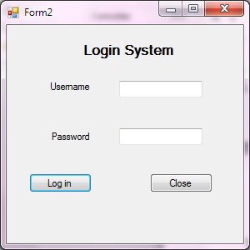

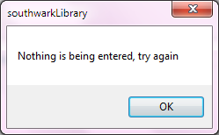

Test 2

Private Sub Button2_Click(sender As Object, e As EventArgs) Handles Button2.Click

Me.Close()

'the form closes after the user finishes using it

'the user can't go back to form 1 now

End Sub



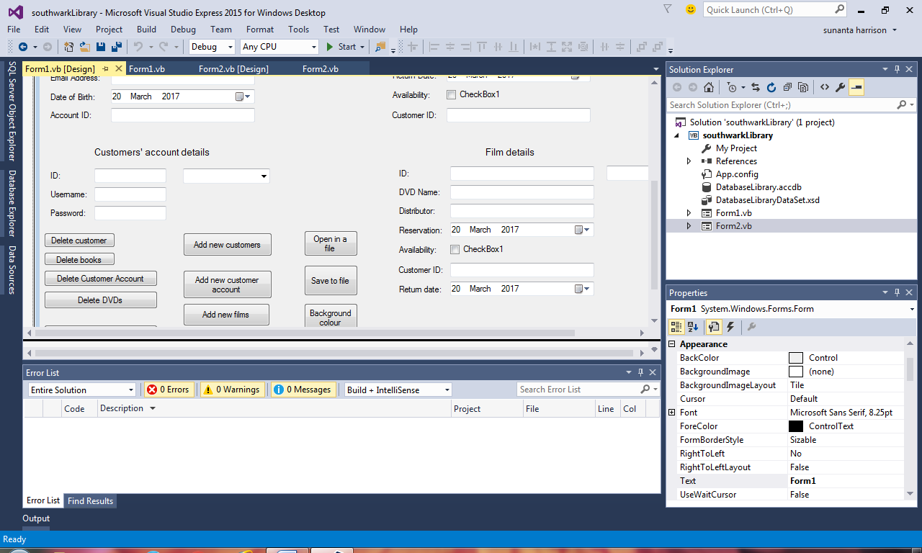Test 3

Ways of trying to correct code:

Private Sub ButtonDeleteCustomer_Click(sender As Object, e As EventArgs) Handles ButtonDeleteCustomer.Click

Try

ButtonDeleteCustomer.PerformClick()

MsgBox("customer data deleted")

Catch ex As Exception

MsgBox(ex.Message)

End Try

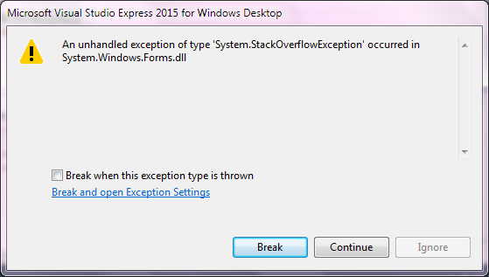 End Sub

Correcting the code at the bottom since the code was difficult for me since it failed the perform the delete customer task. The other solutions I used didn’t perform the task.

Private Sub ButtonDeleteCustomer_Click(sender As Object, e As EventArgs) Handles ButtonDeleteCustomer.Click

If MsgBox("Do you want the delete the selected user", MsgBoxStyle.YesNo, "CONFIRM DELETE") = MsgBoxResult.No Then Exit Sub

Me.IDTextBox.Text = ""

Me.First_NameTextBox.Text = ""

Me.Last_NameTextBox.Text = ""

Me.Home_AddressTextBox.Text = ""

Me.Phone_NumberTextBox.Text = ""

Me.Email_AddressTextBox.Text = ""

Me.AccountIDTextBox.Text = ""

Me.IDTextBox.Focus()

Me.ComboBox1.Text = ""

ComboBox1.Visible = True

ComboBox2.Visible = True

ComboBox3.Visible = True

ComboBox4.Visible = True

'the user has a choice to delete a member

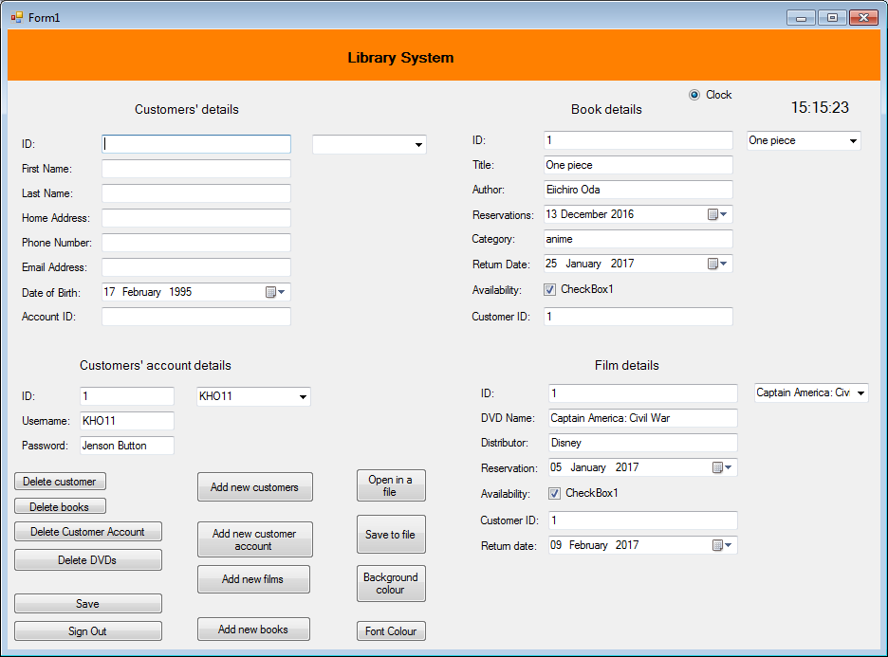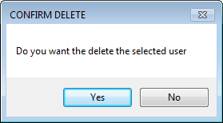 End Sub

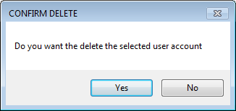Test 4

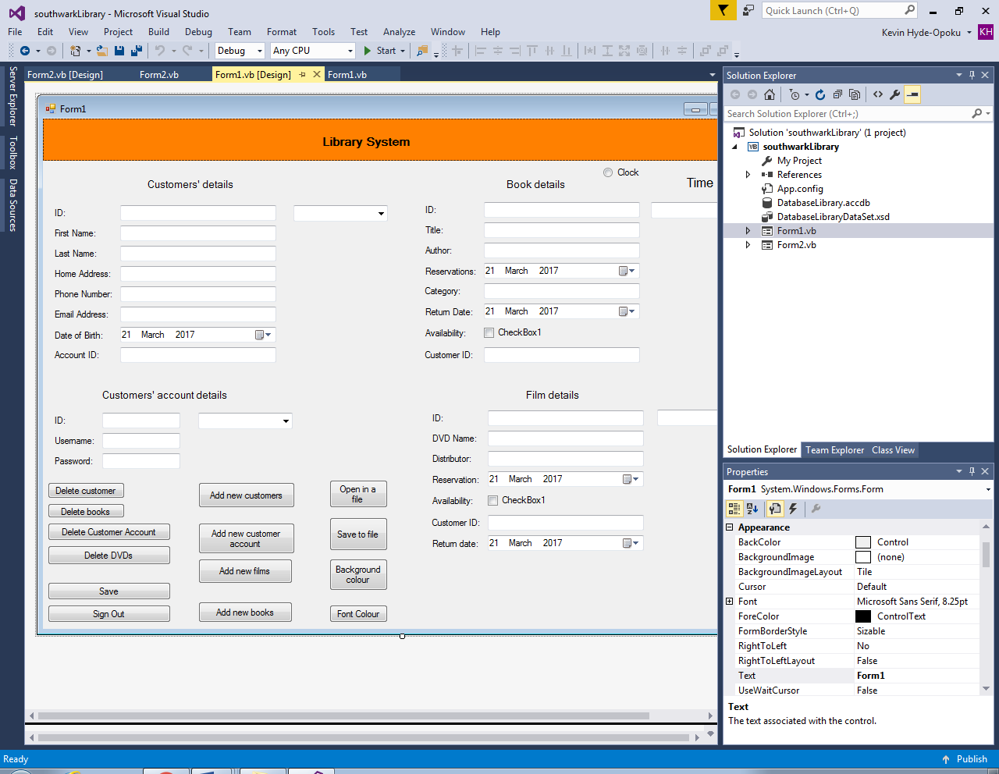

Private Sub ButtonAccountDelete_Click(sender As Object, e As EventArgs) Handles ButtonAccountDelete.Click

If MsgBox("Do you want the delete the selected user account", MsgBoxStyle.YesNo, "CONFIRM DELETE") = MsgBoxResult.No Then Exit Sub

Me.IDTextBox2.Text = ""

Me.UsernameTextBox.Text = ""

Me.PasswordTextBox.Text = ""

Me.IDTextBox2.Focus()

Me.ComboBox3.Text = ""

ComboBox1.Visible = True

ComboBox2.Visible = True

ComboBox3.Visible = True

ComboBox4.Visible = True

End Sub

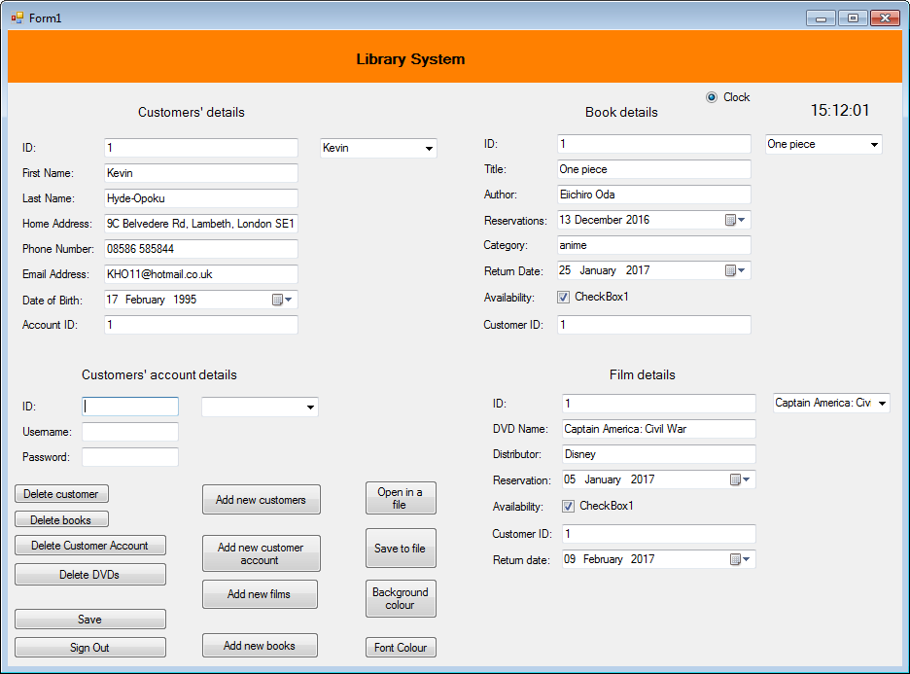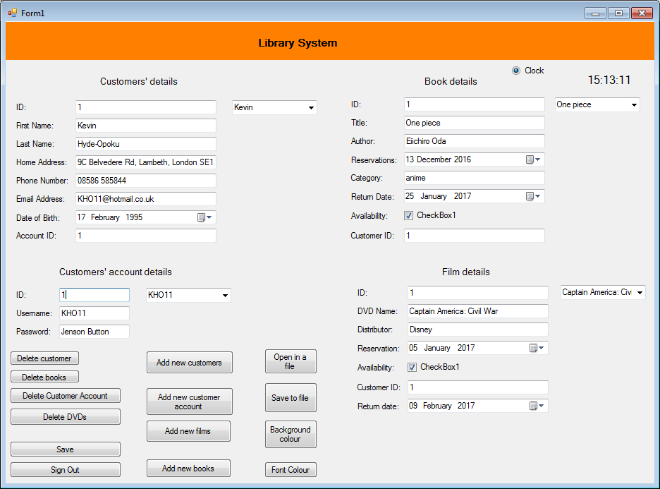

Test 5

Private Sub ButtonDeleteBooks_Click(sender As Object, e As EventArgs) Handles ButtonDeleteBooks.Click

Me.IDTextBox1.Text = ""

Me.TitleTextBox.Text = ""

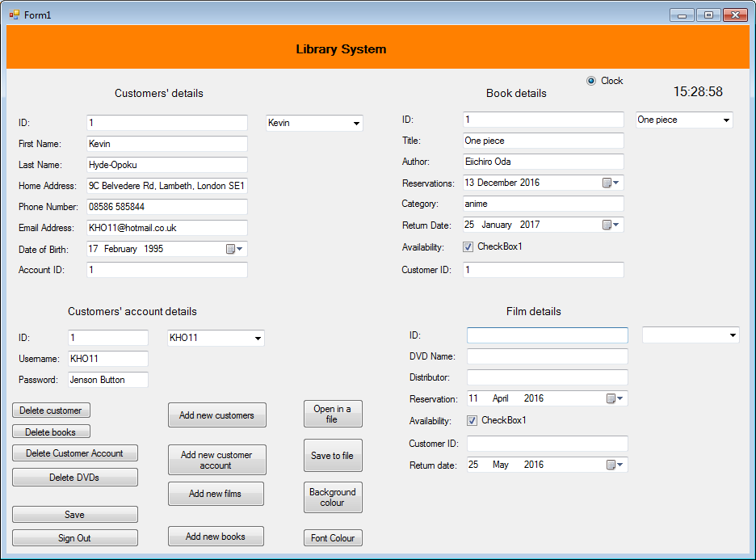 Me.AuthorTextBox.Text = ""

Me.CategoryTextBox.Text = ""

Me.CustomerIDTextBox.Text = ""

Me.ComboBox2.Text = ""

End Sub

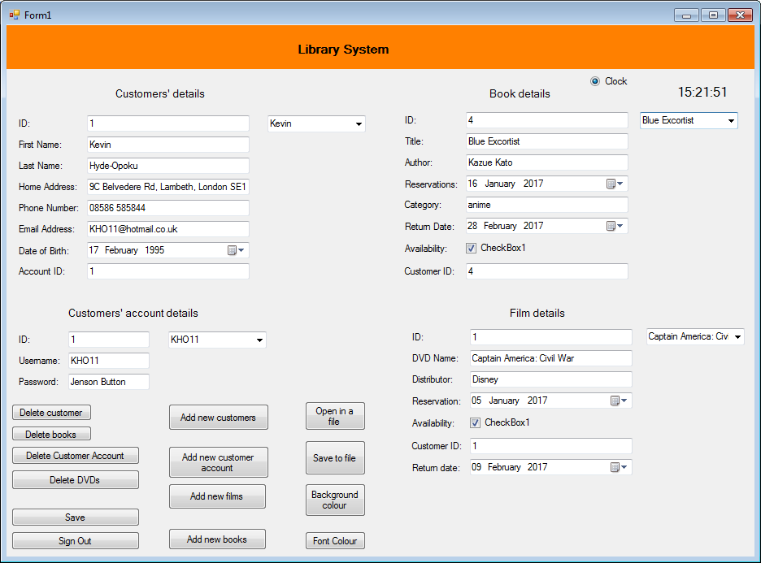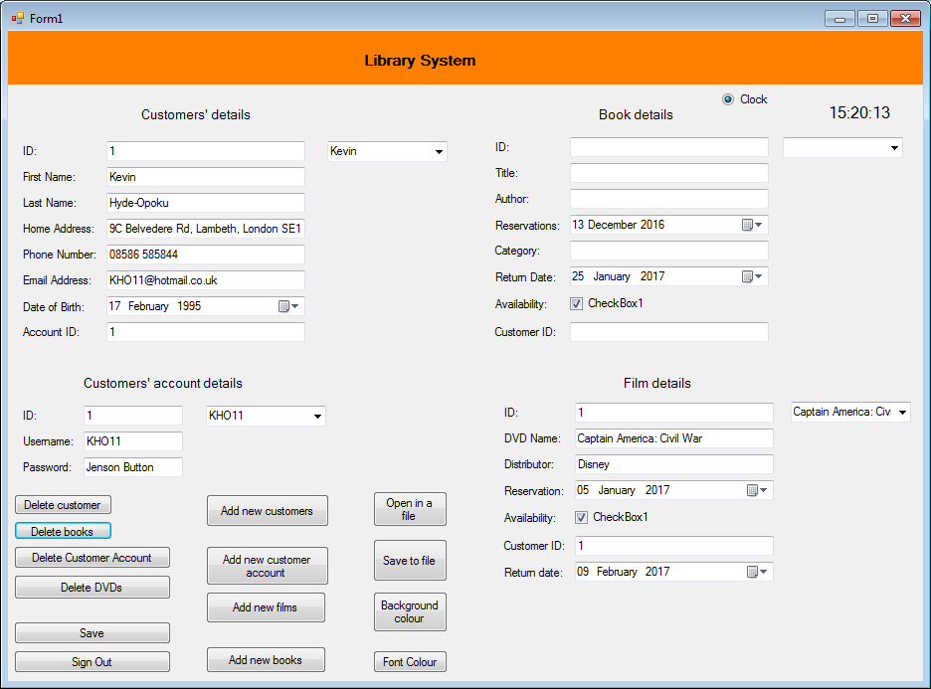

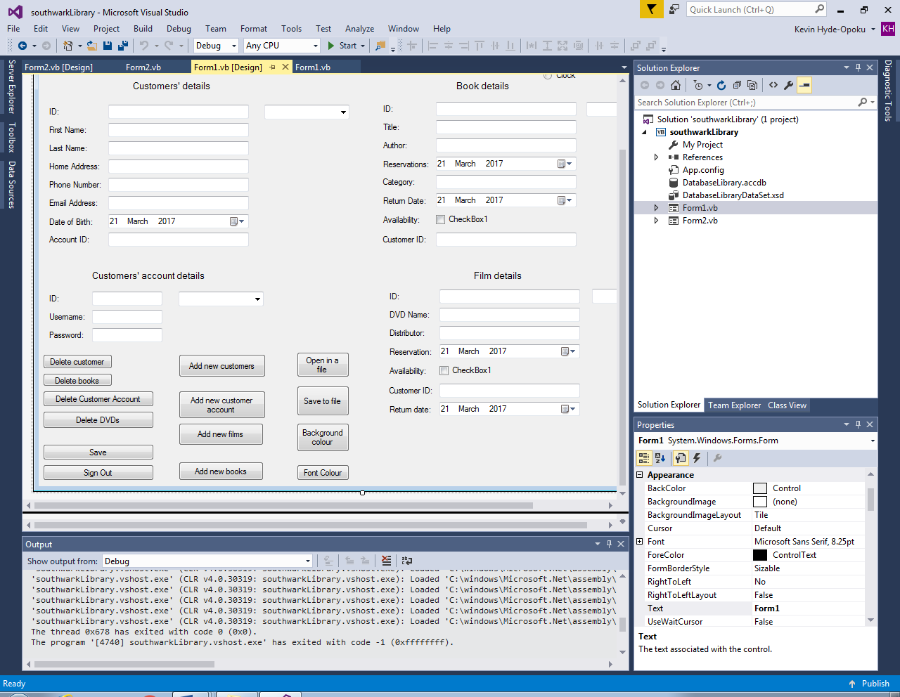Test 6

Private Sub ButtonDeleteDVDs_Click(sender As Object, e As EventArgs) Handles ButtonDeleteDVDs.Click

Me.IDTextBox3.Text = ""

Me.DVD_NameTextBox.Text = ""

Me.DistributorTextBox.Text = ""

Me.CustomerIDTextBox1.Text = ""

Me.ComboBox4.Text = ""

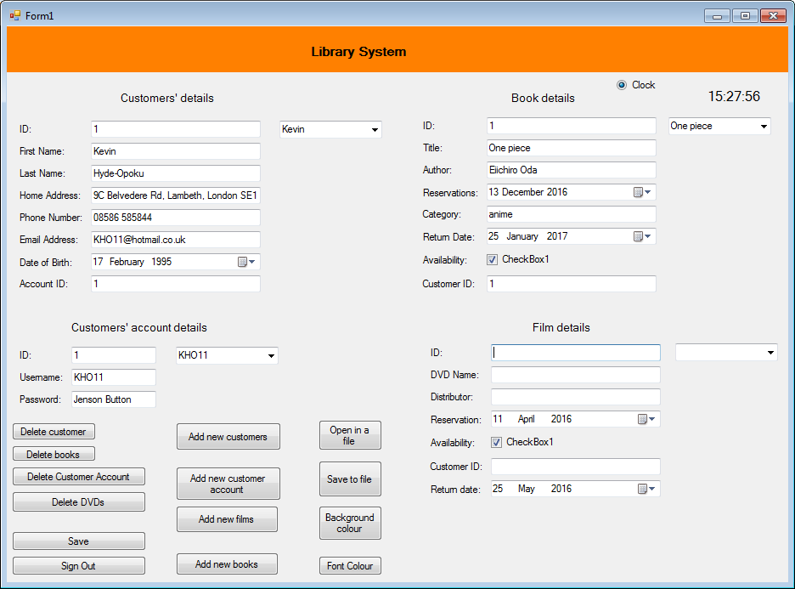 End Sub

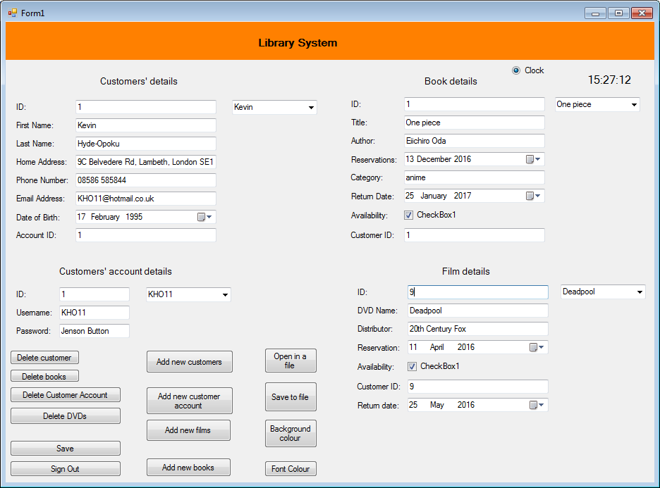

Test 7

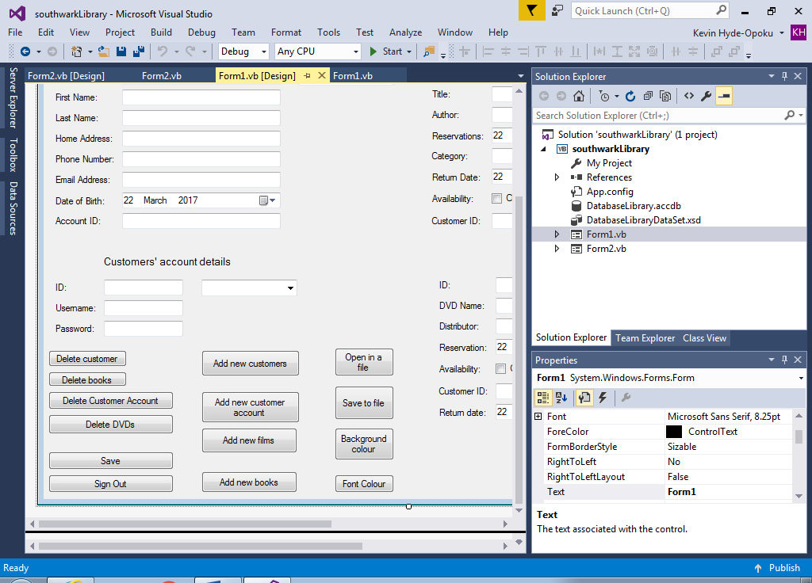

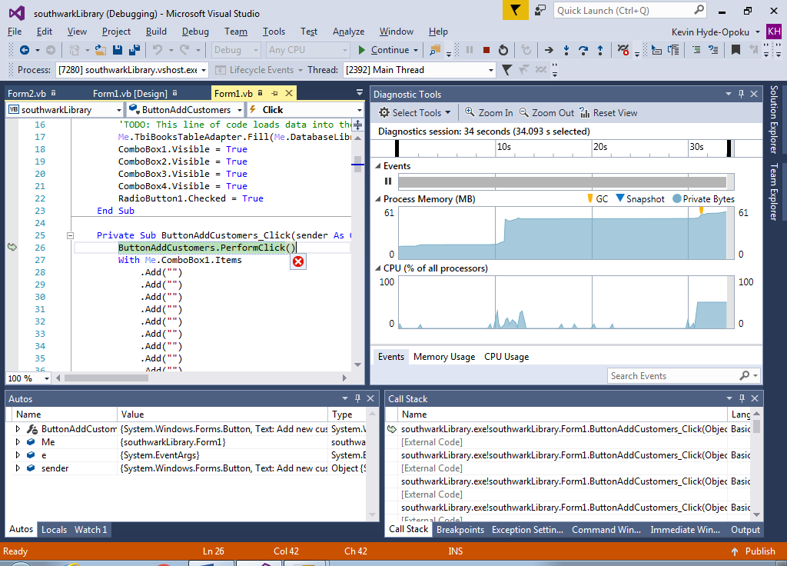Private Sub ButtonAddCustomers_Click(sender As Object, e As EventArgs) Handles ButtonAddCustomers.Click

ButtonAddCustomers.PerformClick()

With Me.ComboBox1.Items

.Add("")

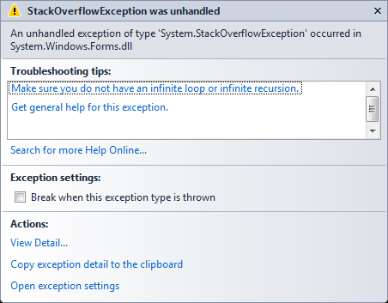 .Add("")

.Add("")

.Add("")

.Add("")

.Add("")

.Add("")

.Add("")

.Add("")

.Add("")

'the user can't add more than ten new customers

End With

End Sub

I struggled to correct the code for the add customers option as I couldn’t find any ways to correct it. I used a loop that enables the librarian to add as many customers into the system repeatedly until he/she finishes adding them.

Other ways of correcting code:

Private Sub ButtonAddCustomer_Click(sender As Object, e As EventArgs) Handles ButtonAddCustomer.Click

Try

ButtonAddCustomer.PerformClick()

MsgBox("customer data added")

Catch ex As Exception

MsgBox(ex.Message)

End Try

End Sub

Private Sub ButtonAddCustomers_Click(sender As Object, e As EventArgs) Handles ButtonAddCustomers.Click

For x = 1 To 10

ButtonAddCustomers.PerformClick()

Next

End Sub

Correction:

Private Sub ButtonAddCustomers_Click(sender As Object, e As EventArgs) Handles ButtonAddCustomers.Click

Form3.Show()

Me.Hide()

'ButtonAddCustomerAccount.PerformClick()

'With Me.ComboBox1.Items

'.Add("")

'.Add("")

'.Add("")

'.Add("")

'.Add("")

'.Add("")

'.Add("")

'.Add("")

'.Add("")

'.Add("")

'the user can't add more than ten new customer accounts

'End With

End Sub

Test 8

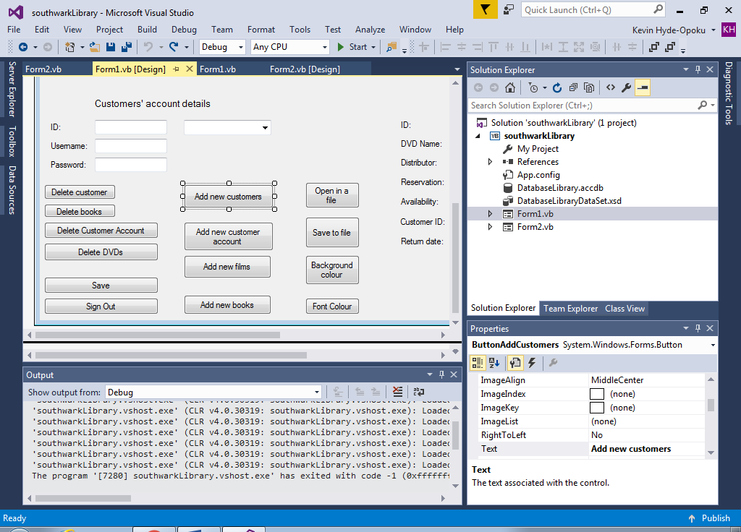

Private Sub ButtonAddCustomerAccount_Click(sender As Object, e As EventArgs) Handles ButtonAddCustomerAccount.Click

ButtonAddCustomerAccount.PerformClick()

With Me.ComboBox2.Items

.Add("")

.Add("")

.Add("")

.Add("")

.Add("")

.Add("")

.Add("")

.Add("")

.Add("")

.Add("")

'the user can't add more than ten new customer accounts

End With

End Sub

Other ways of correcting the code:

Private Sub ButtonAddCustomerAccount_Click(sender As Object, e As EventArgs) Handles ButtonAddCustomerAccount.Click

ButtonAddCustomerAccount.PerformClick()

End Sub

Correction:

Private Sub ButtonAddCustomerAccount_Click(sender As Object, e As EventArgs) Handles ButtonAddCustomerAccount.Click

Form4.Show()

Me.Hide()

'With Me.ComboBox2.Items

'.Add("")

'.Add("")

'.Add("")

'.Add("")

'.Add("")

'.Add("")

'.Add("")

'.Add("")

'.Add("")

'.Add("")

'the user can't add more than ten new customer accounts

'End With

End Sub

Test 9

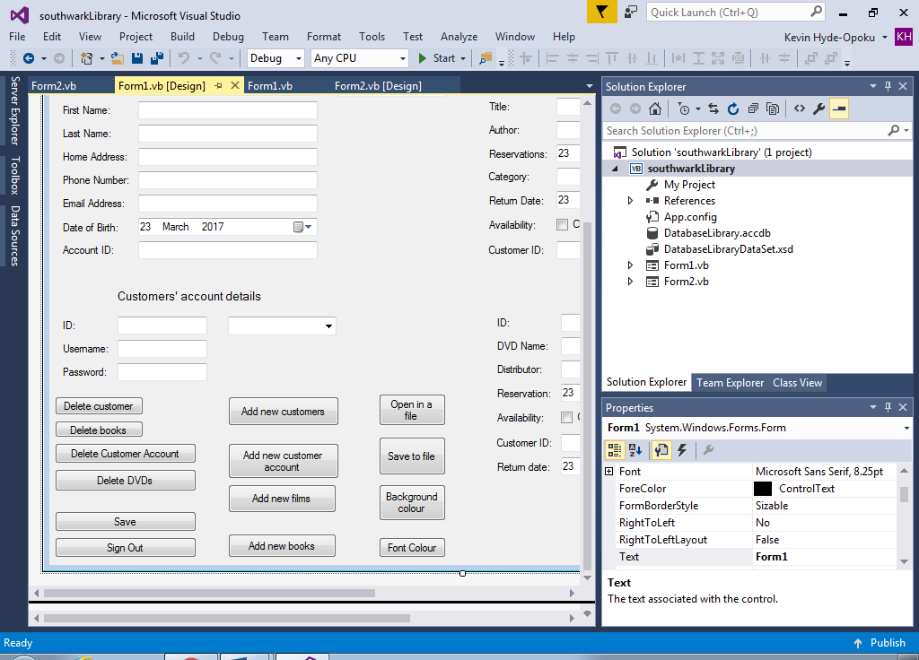

Private Sub ButtonAddFilms_Click(sender As Object, e As EventArgs) Handles ButtonAddFilms.Click

ButtonAddFilms.PerformClick()

With Me.ComboBox3.Items

.Add("")

.Add("")

.Add("")

.Add("")

.Add("")

.Add("")

.Add("")

.Add("")

.Add("")

.Add("")

'the user can't add more than ten new films

End With

End Sub

Other ways of correcting code:

Private Sub ButtonAddFilms_Click(sender As Object, e As EventArgs) Handles ButtonAddFilms.Click

ButtonAddFilms.PerformClick()



End Sub

Correction:

Private Sub ButtonAddFilms_Click(sender As Object, e As EventArgs) Handles ButtonAddFilms.Click

Form6.Show()

Me.Hide()

'ButtonAddFilms.PerformClick()

'With Me.ComboBox3.Items

'.Add("")

'.Add("")

'.Add("")

'.Add("")

'.Add("")

'.Add("")

'.Add("")

'.Add("")

'.Add("")

'.Add("")

'the user can't add more than ten new films

'End With

End Sub

Test 10

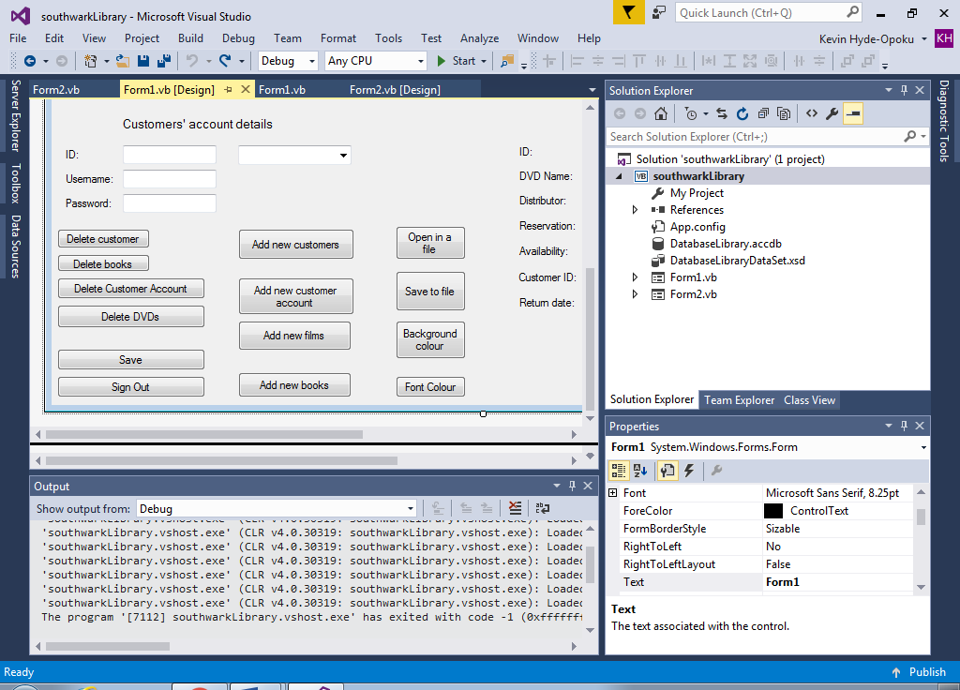

Private Sub ButtonAddBooks_Click(sender As Object, e As EventArgs) Handles ButtonAddBooks.Click

 ButtonAddBooks.PerformClick()

With Me.ComboBox4.Items

.Add("")

.Add("")

.Add("")

.Add("")

.Add("")

.Add("")

.Add("")

.Add("")

.Add("")

.Add("")

'the user can't add ten new books

End With

End Sub

Other ways of correcting code:

Private Sub ButtonAddBooks_Click(sender As Object, e As EventArgs) Handles ButtonAddBooks.Click

ButtonAddBooks.PerformClick()

End Sub

Correction:

Private Sub ButtonAddBooks_Click(sender As Object, e As EventArgs) Handles ButtonAddBooks.Click

Form5.Show()

Me.Hide()

'ButtonAddBooks.PerformClick()

'With Me.ComboBox4.Items

'.Add("")

'.Add("")

'.Add("")

'.Add("")

'.Add("")

'.Add("")

'.Add("")

'.Add("")

'.Add("")

'.Add("")

'the user can't add ten new books

'End With

End Sub

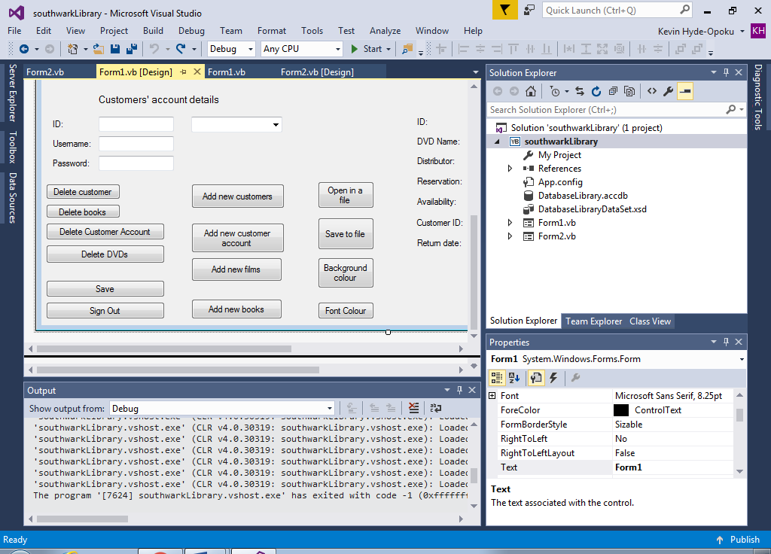Test 11

Private Sub ButtonOpenFile_Click(sender As Object, e As EventArgs) Handles ButtonOpenFile.Click

Dim FileReader As StreamReader

Dim results As DialogResult

results = OpenFileDialog1.ShowDialog

If results = DialogResult.OK Then

FileReader = New StreamReader(OpenFileDialog1.FileName)

FileReader.Close()

End If

End Sub

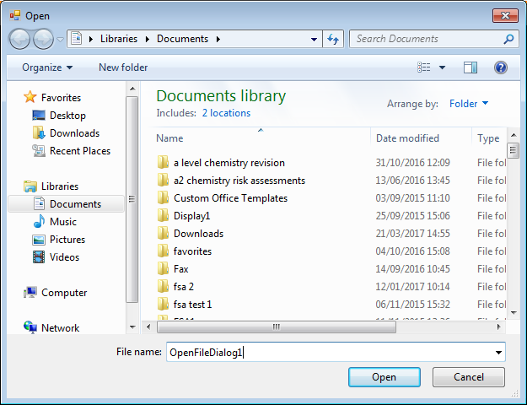I created an open file code first time and the code performed the task I wanted it to do. I wanted the user to open the database from the file that has already been previously saved.

Test 12



Private Sub ButtonSaveFile_Click(sender As Object, e As EventArgs) Handles ButtonSaveFile.Click

Dim FileWriter As StreamWriter

Dim results As DialogResult

results = SaveFileDialog1.ShowDialog

If results = DialogResult.OK Then

FileWriter = New StreamWriter(SaveFileDialog1.FileName, False)

FileWriter.Close()

End If

End Sub

I created the save file first time and the code performed the job I wanted it to do. I wanted the user to save the database into the file after the user finishes uses the data.

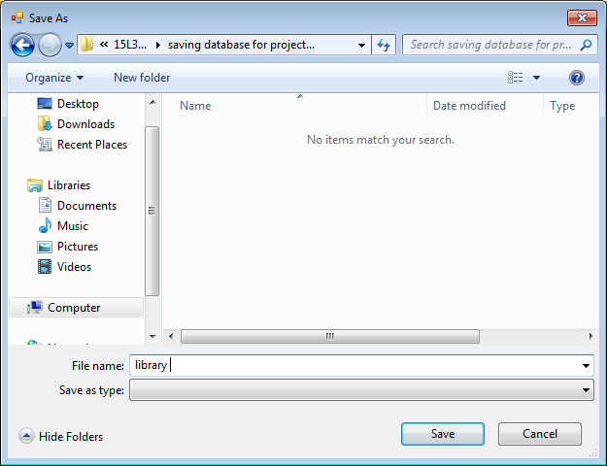

Test 13

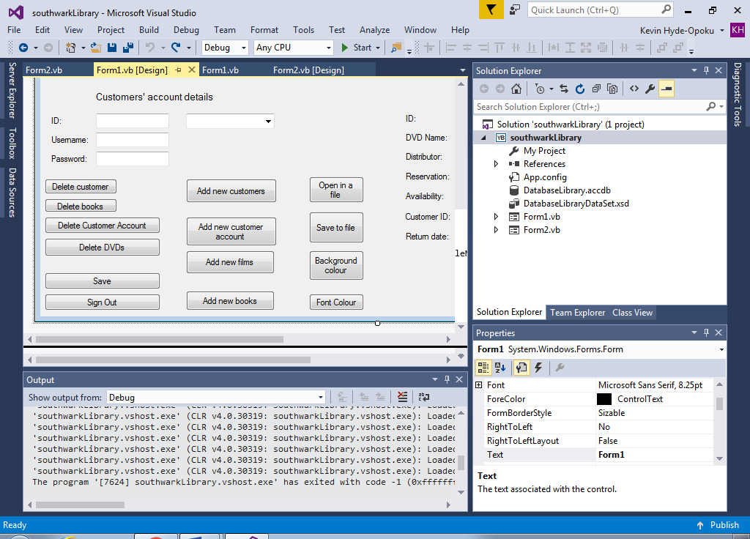

Private Sub ButtonBackground_Click(sender As Object, e As EventArgs) Handles ButtonBackground.Click

If ColorBackground.ShowDialog = DialogResult.OK Then

Me.BackColor = ColorBackground.Color

'The user has a choice to choose any background colour he prefers

' Different range of colours

End If

End Sub

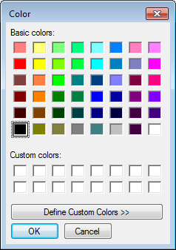

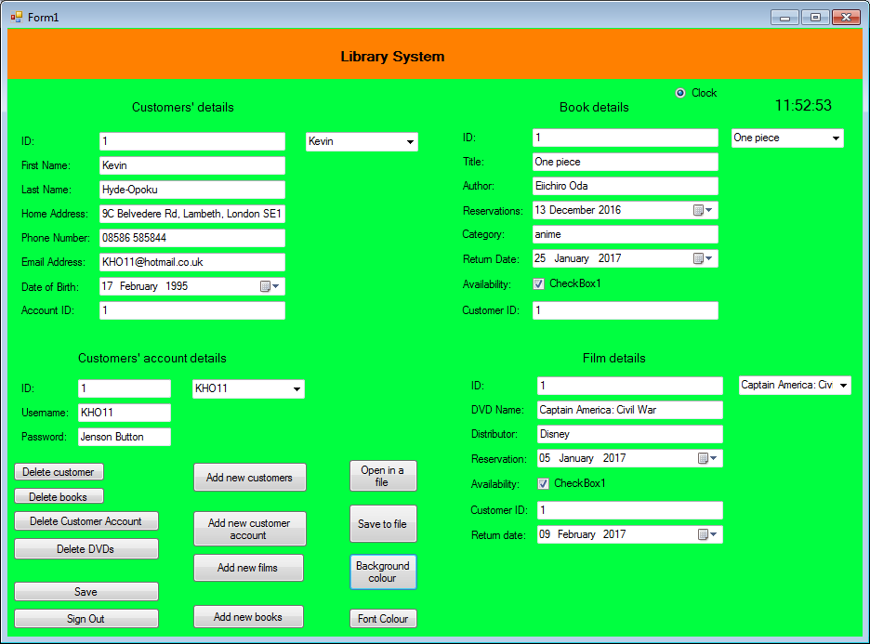

Test 14

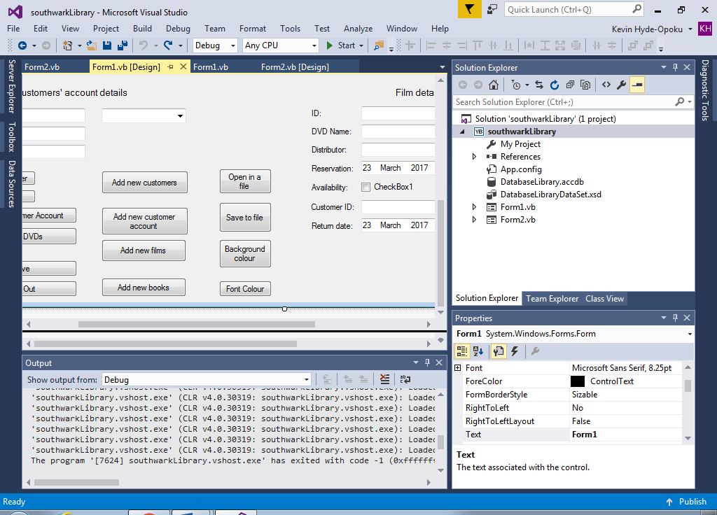

Private Sub ButtonFontColour_Click(sender As Object, e As EventArgs) Handles ButtonFontColour.Click

If ColorBackground.ShowDialog = DialogResult.OK Then

IDTextBox.ForeColor = ColorBackground.Color

First_NameTextBox.ForeColor = ColorBackground.Color

Last_NameTextBox.ForeColor = ColorBackground.Color

Home_AddressTextBox.ForeColor = ColorBackground.Color

Phone_NumberTextBox.ForeColor = ColorBackground.Color

Email_AddressTextBox.ForeColor = ColorBackground.Color

Date_of_BirthDateTimePicker.ForeColor = ColorBackground.Color

AccountIDTextBox.ForeColor = ColorBackground.Color

ComboBox1.ForeColor = ColorBackground.Color

'changing the font colour for the customers' details section

IDTextBox1.ForeColor = ColorBackground.Color

TitleTextBox.ForeColor = ColorBackground.Color

AuthorTextBox.ForeColor = ColorBackground.Color

ReservationsDateTimePicker.ForeColor = ColorBackground.Color

CategoryTextBox.ForeColor = ColorBackground.Color

Return_DateDateTimePicker.ForeColor = ColorBackground.Color

CustomerIDTextBox.ForeColor = ColorBackground.Color

ComboBox2.ForeColor = ColorBackground.Color

'changing the font colour for the books' details section

IDTextBox2.ForeColor = ColorBackground.Color

UsernameTextBox.ForeColor = ColorBackground.Color

PasswordTextBox.ForeColor = ColorBackground.Color

ComboBox3.ForeColor = ColorBackground.Color

'changing the font colour for the customers' account section

IDTextBox3.ForeColor = ColorBackground.Color

DVD_NameTextBox.ForeColor = ColorBackground.Color

DistributorTextBox.ForeColor = ColorBackground.Color

ReservationDateTimePicker.ForeColor = ColorBackground.Color

CustomerIDTextBox1.ForeColor = ColorBackground.Color

Return_dateDateTimePicker1.ForeColor = ColorBackground.Color

ComboBox4.ForeColor = ColorBackground.Color

'changing the font colour for the film details' section

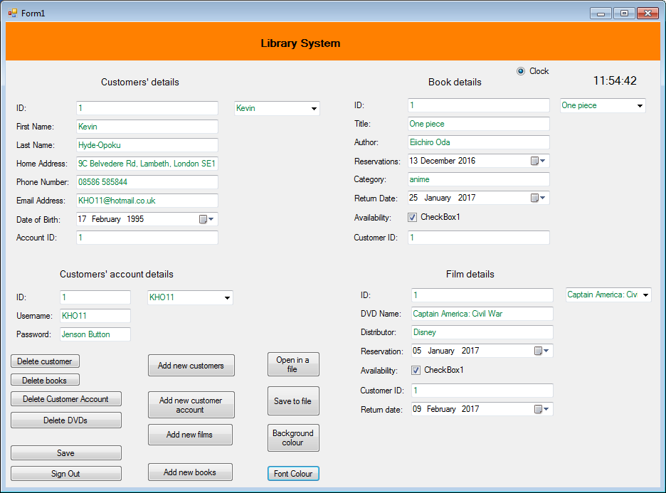 End If

End Sub

Test 15

Private Sub ButtonSave_Click(sender As Object, e As EventArgs) Handles ButtonSave.Click

Me.Validate()

Me.TbiCustomersBindingSource.EndEdit()

Me.TbiCustomersAccountBindingSource.EndEdit()

Me.TbiDVDsBindingSource.EndEdit()

Me.TbiBooksBindingSource.EndEdit()

Me.TbiCustomersTableAdapter.Update(Me.DatabaseLibraryDataSet)

Me.TbiBooksTableAdapter.Update(Me.DatabaseLibraryDataSet)

Me.TbiDVDsTableAdapter.Update(Me.DatabaseLibraryDataSet)

Me.TbiCustomersAccountTableAdapter.Update(Me.DatabaseLibraryDataSet)

MsgBox("data saved")

End Sub

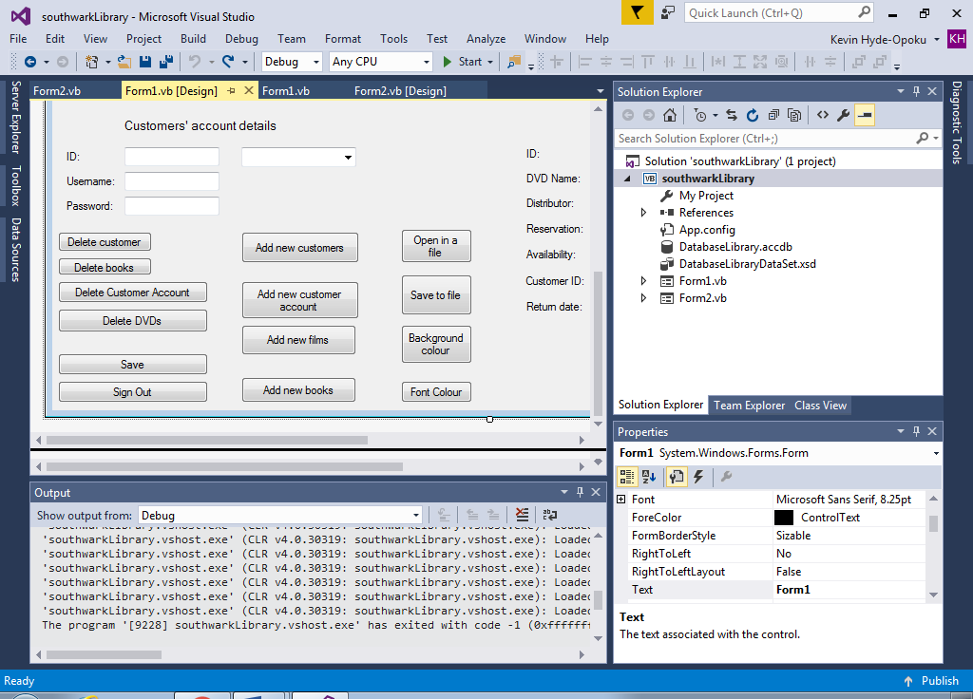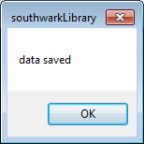

Test 16

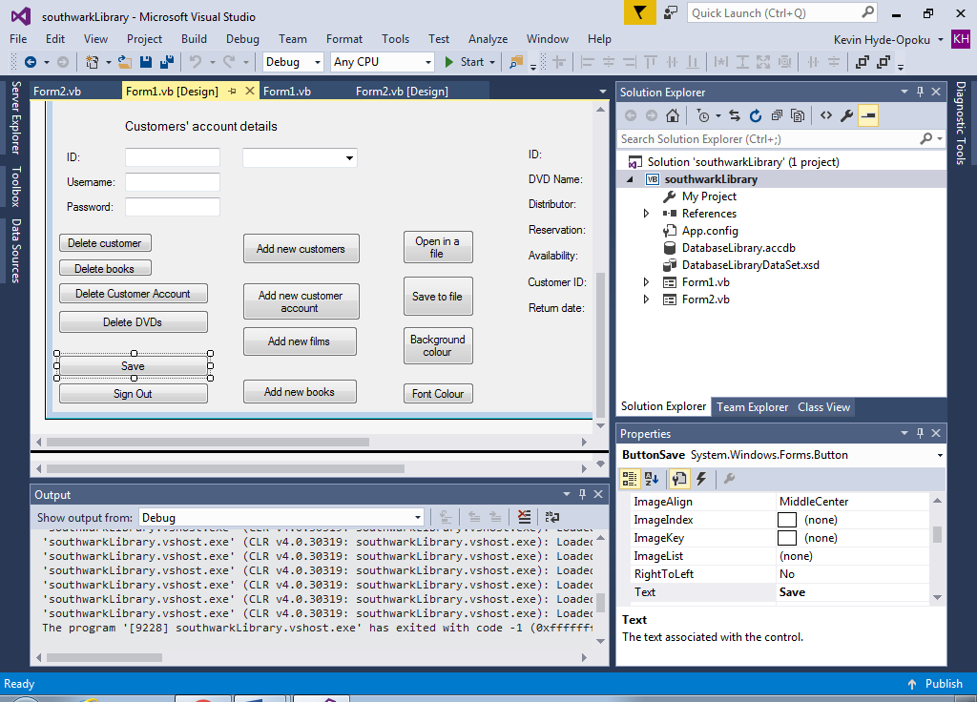

Private Sub ButtonSignOut_Click(sender As Object, e As EventArgs) Handles ButtonSignOut.Click

MsgBox("do you want to log out")

If MsgBoxResult.Yes Then

Me.Close()

'if the user chooses not to log out form 1 will still be open

' the user has a choice whenever he/she finishes using it

End If

End Sub

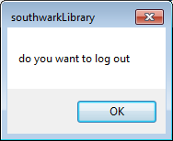

Test 17

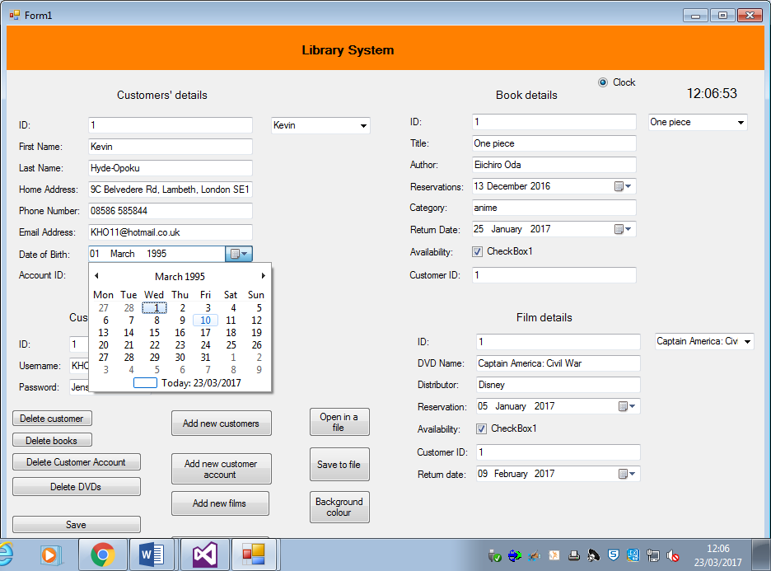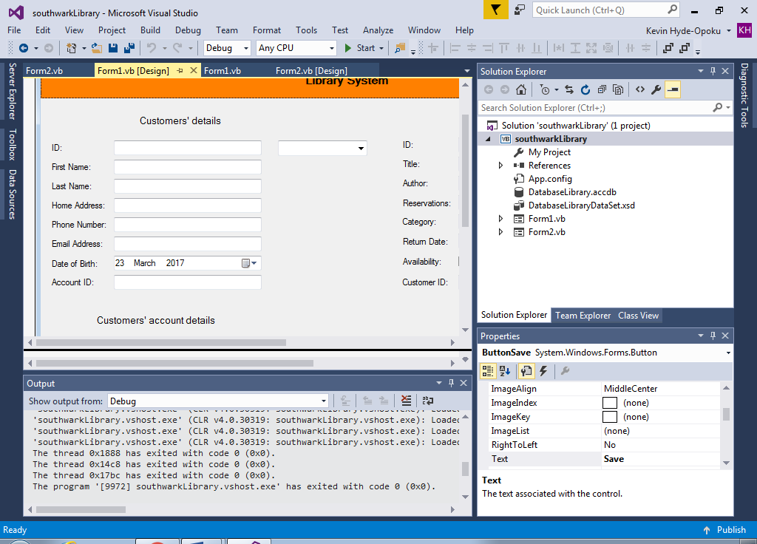

Test 18

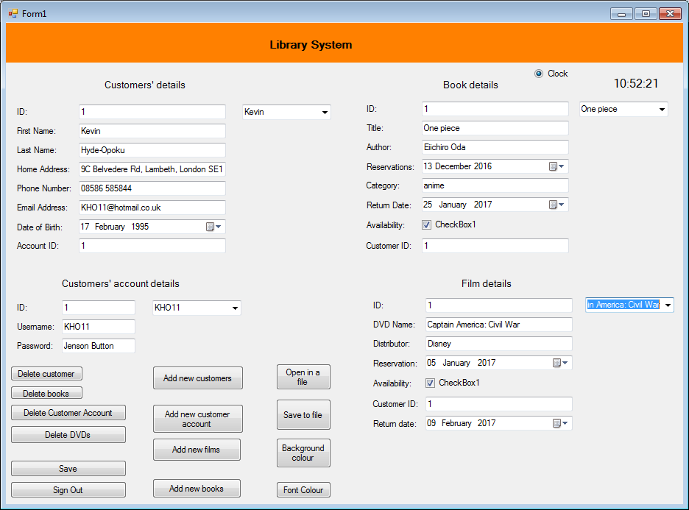

**System Maintenance**

**System overview**

The system’s installation will have a server which will store the backup files on a different site. The command interface can only be accessed by the installation engineers.

The command interface will be used by the engineers on a six months serving option; but the librarians will be instructed to serve a daily backup file on the main server at the close business.

The computer system is made up of hardware and software. It is capable of data input devices which involves a keyboard, barcode reader and a mouse. Its data output devices involve a computer monitor, speakers and printer. The barcode scanner uses a pattern of dark and light parallel lines of different thickness to erode a number. It’s a fast and accurate capture of numerical dates.

The keyboard uses labelled buttons as input switches. The QWERTY keyboard is an easier way to enter text and numerical data into a compiler.

My system contains two main pages for the login and the library system. Once the user logs in to the library system, the library form which is the main page shows information of library resources and members of the Southwark library. The user (librarian) can change the library resources if they’re no longer in the library and the members’ details if the member suggest it otherwise. The main page shows the other options for the librarian to do on the system. They can add or delete details that they think is necessary.

The user cannot be a member or customer since they can hack the library system by using members’ information for blackmail, fraud, identity theft and etc. Doing that will affect the library system and members; it can put members at risk.

I didn’t create a library system for customers since I had difficulties in figuring out how to write the code for it, without increasing the errors and operational risks in the system. Providing the library system for librarians is my main priority, therefore I didn’t over complicate the code by implementing member user friendly forms.

**Procedure list**

|  |  |  |  |
| --- | --- | --- | --- |
| Item | Name | Description | Parameters |
| Procedure | TbiBooksBindingNavigatorSaveItem_Click | Updates data on books | No parameters |
| Function | ButtonAddCustomers | Add new members to the database | Passes the new customers |
| Function | ButtonAddCustomerAccount | Add new customers’ accounts to the database | Passes new customer account |
| Function | ButtonAddFilms | Add new films to the database | Passes new films |
| Function | ButtonAddBooks | Add new books to the database | Passes new books |
| Procedure | ButtonSave | Saves information | Passes the saved information |
| Function | ButtonDeleteCustomer | Deletes customers from the database | Passes customer information that have been deleted |
| Function | ButtonAccountDelete | Deletes customers’ accounts from the database | Passes information on customer account that have been deleted |
| Function | ButtonDeleteDVDs | Deletes DVDs from the database | Passes details on films that have been deleted |
| Function | ButtonDeleteBooks | Deletes books from the database | Passes details on books that have been deleted |
| Procedure | ButtonSignOut | Signs the user out of the database | No parameter passed |
| Function | ButtonBackground_Click | Allows the user to choose a background colour | Passes the background colour choice |
| Function | ButtonFontColour | Allows the user to choose a font colour | Passes the font colour choice |
| Procedure | ButtonSaveFile_Click | The user has the option to save the database in any file | No parameters passed |
| Procedure | ButtonOpenFile_Click | Opens the database from the file where it has been previously saved. | No parameters passed |

**Variable list**

|  |  |  |  |
| --- | --- | --- | --- |
| **Variable** | **Data type** | **Used for** | **Comment** |
| IDTextBox.Text | Integer | Identifying members | Store members |
| First_NameTextBox.Text | String | Name of a member | Store first names of members |
| Last_NameTextBox.Text | String | Name of a member | Store last names of members |
| Home_AddressTextBox.Text | String | Home address of a member | Stores the address of where members live |
| Phone_NumberTextBox.Text | Integer | Identifying the phone number of a member | Stores the phone number of a member |
| Email_AddressTextBox.Text | String | Email address of a member | Stores the email address of a member |
| AccountIDTextBox.Text | Integer | Identifying members’ accounts | Stores the members’ library account |
| ComboBox1.Text | String | Lists library members | Stores library members |
| UsernameTextBox.Text | String | Username of a library member | Stores the username in the database system |
| PasswordTextBox.Text | String | Password of a library member | Stores the password in the database system |
| ComboBox3.Text | String | Lists the library members’ accounts | Stores the members’ account details in the database system. |
| IDTextBox3.Text | Integer | Identifies films | Stores films in the system |
| DVD_NameTextBox.Text | String | Name of a film | Stores the name of films in the database system |
| DistributorTextBox.Text | String | Distributor of films | Stores the name of distributors on the system |
| ComboBox4.Text | String | Lists the name of films | Stores films in the database system |
| TitleTextBox.Text | String | Name of a book | Stores the name of books in the system |
| AuthorTextBox.Text | String | Writer of a book | Stores the writers’ name and books they’ve published |
| CategoryTextBox.Text | String | Used to determine a category a book belongs to | Stores the category |
| ComboBox2.Text | String | Lists the books | Stores books |

Public Class Form2

Private Sub Button1_Click(sender As Object, e As EventArgs) Handles Button1.Click

If TextBoxUsername.Text = "admin" And TextBoxPassword.Text = "qwerty" Then

MsgBox("Logged in")

Form1.Show()

'the library system form will show after the user logs in.

ElseIf TextBoxUsername.Text = "" And TextBoxPassword.Text = "" Then

MsgBox("Nothing is being entered, try again")

'user failing to enter anything to prevent him/her from being logged in

Else

MsgBox("Wrong username or password, TRY AGAIN!")

'user failing to log in

End If

End Sub

Private Sub Button2_Click(sender As Object, e As EventArgs) Handles Button2.Click

Me.Close()

'the form closes after the user finishes using it

'the user can't go back to form 1 now

End Sub

End Class

If username= “admin” and password = “qwerty” then

User logged in

Else if username=”” and password = “” then

User cannot log in, try again

Else

User cannot log in, try again

End If

Public Class Form1

Private Sub TbiBooksBindingNavigatorSaveItem_Click(sender As Object, e As EventArgs)

Me.Validate()

Me.TbiBooksBindingSource.EndEdit()

Me.TableAdapterManager.UpdateAll(Me.DatabaseLibraryDataSet)

End Sub

Procedure form 1

Checks if data is official

Checks the data stored for books

Updates the database tables

End Procedure

Private Sub Form1_Load(sender As Object, e As EventArgs) Handles MyBase.Load

'TODO: This line of code loads data into the 'DatabaseLibraryDataSet.TbiDVDs' table. You can move, or remove it, as needed.

Me.TbiDVDsTableAdapter.Fill(Me.DatabaseLibraryDataSet.TbiDVDs)

'TODO: This line of code loads data into the 'DatabaseLibraryDataSet.TbiCustomersAccount' table. You can move, or remove it, as needed.

Me.TbiCustomersAccountTableAdapter.Fill(Me.DatabaseLibraryDataSet.TbiCustomersAccount)

'TODO: This line of code loads data into the 'DatabaseLibraryDataSet.TbiCustomers' table. You can move, or remove it, as needed.

Me.TbiCustomersTableAdapter.Fill(Me.DatabaseLibraryDataSet.TbiCustomers)

'TODO: This line of code loads data into the 'DatabaseLibraryDataSet.TbiBooks' table. You can move, or remove it, as needed.

Me.TbiBooksTableAdapter.Fill(Me.DatabaseLibraryDataSet.TbiBooks)

Procedure form 1 load

Data on films loaded on the database system = true

Data on customer account loaded on the database system = true

Data on members is loaded on the database system = true

Data on books is loaded on the database system = true

End Procedure

Private Sub ButtonAddCustomers_Click(sender As Object, e As EventArgs) Handles ButtonAddCustomers.Click

ButtonAddCustomers.PerformClick()

With Me.ComboBox1.Items

.Add("")

.Add("")

.Add("")

.Add("")

.Add("")

.Add("")

.Add("")

.Add("")

.Add("")

.Add("")

'the user can't add more than ten new customers

End With

End Sub

Function add customers

Output (Add maximum 10 customers)

Output (customer)

End Function

Private Sub ButtonAddCustomerAccount_Click(sender As Object, e As EventArgs) Handles ButtonAddCustomerAccount.Click

ButtonAddCustomerAccount.PerformClick()

With Me.ComboBox2.Items

.Add("")

.Add("")

.Add("")

.Add("")

.Add("")

.Add("")

.Add("")

.Add("")

.Add("")

.Add("")

'the user can't add more than ten new customer accounts

End With

End Sub

Function add customer account

Output (Add maximum 10 customer account)

Output (customer account)

End Function

Private Sub ButtonAddFilms_Click(sender As Object, e As EventArgs) Handles ButtonAddFilms.Click

ButtonAddFilms.PerformClick()

With Me.ComboBox3.Items

.Add("")

.Add("")

.Add("")

.Add("")

.Add("")

.Add("")

.Add("")

.Add("")

.Add("")

.Add("")

'the user can't add more than ten new films

End With

End Sub

Function add films

Output (Add maximum 10 films)

Output (films)

End Function

Private Sub ButtonAddBooks_Click(sender As Object, e As EventArgs) Handles ButtonAddBooks.Click

ButtonAddBooks.PerformClick()

With Me.ComboBox4.Items

.Add("")

.Add("")

.Add("")

.Add("")

.Add("")

.Add("")

.Add("")

.Add("")

.Add("")

.Add("")

'the user can't add ten new books

End With

End Sub

Function add books

Output (Add maximum 10 books)

Output (books)

End Function

Private Sub ButtonSave_Click(sender As Object, e As EventArgs) Handles ButtonSave.Click

Me.Validate()

Me.TbiCustomersBindingSource.EndEdit()

Me.TbiCustomersAccountBindingSource.EndEdit()

Me.TbiDVDsBindingSource.EndEdit()

Me.TbiBooksBindingSource.EndEdit()

Me.TbiCustomersTableAdapter.Update(Me.DatabaseLibraryDataSet)

Me.TbiBooksTableAdapter.Update(Me.DatabaseLibraryDataSet)

Me.TbiDVDsTableAdapter.Update(Me.DatabaseLibraryDataSet)

Me.TbiCustomersAccountTableAdapter.Update(Me.DatabaseLibraryDataSet)

MsgBox("data saved")

End Sub

Procedure save details

Output (saved details)

End procedure

Private Sub ButtonDeleteCustomer_Click(sender As Object, e As EventArgs) Handles ButtonDeleteCustomer.Click

If MsgBox("Do you want the delete the selected user", MsgBoxStyle.YesNo, "CONFIRM DELETE") = MsgBoxResult.No Then Exit Sub

Me.IDTextBox.Text = ""

Me.First_NameTextBox.Text = ""

Me.Last_NameTextBox.Text = ""

Me.Home_AddressTextBox.Text = ""

Me.Phone_NumberTextBox.Text = ""

Me.Email_AddressTextBox.Text = ""

Me.AccountIDTextBox.Text = ""

Me.IDTextBox.Focus()

Me.ComboBox1.Text = ""

ComboBox1.Visible = True

ComboBox2.Visible = True

ComboBox3.Visible = True

ComboBox4.Visible = True

'the user has a choice to delete a member

End Sub

Function delete customer

Output (“Do you want to delete the selected user”)

IDTextBox.Text = ""

First_NameTextBox.Text = ""

Last_NameTextBox.Text = ""

Home_AddressTextBox.Text = ""

Phone_NumberTextBox.Text = ""

Email_AddressTextBox.Text = ""

AccountIDTextBox.Text = ""

ComboBox1.Text = ""

End Function

Private Sub ButtonAccountDelete_Click(sender As Object, e As EventArgs) Handles ButtonAccountDelete.Click

If MsgBox("Do you want the delete the selected user account", MsgBoxStyle.YesNo, "CONFIRM DELETE") = MsgBoxResult.No Then Exit Sub

Me.IDTextBox2.Text = ""

Me.UsernameTextBox.Text = ""

Me.PasswordTextBox.Text = ""

Me.IDTextBox2.Focus()

Me.ComboBox3.Text = ""

ComboBox1.Visible = True

ComboBox2.Visible = True

ComboBox3.Visible = True

ComboBox4.Visible = True

End Sub

Function delete customer account

Output (“Do you want to delete the selected user account”)

IDTextBox2.Text = ""

UsernameTextBox.Text = ""

PasswordTextBox.Text = ""

ComboBox3.Text = ""

End Function

Private Sub ButtonDeleteDVDs_Click(sender As Object, e As EventArgs) Handles ButtonDeleteDVDs.Click

Me.IDTextBox3.Text = ""

Me.DVD_NameTextBox.Text = ""

Me.DistributorTextBox.Text = ""

Me.CustomerIDTextBox1.Text = ""

Me.ComboBox4.Text = ""

End Sub

Function delete DVDs

IDTextBox3.Text = ""

DVD_NameTextBox.Text = ""

DistributorTextBox.Text = ""

CustomerIDTextBox1.Text = ""

ComboBox4.Text = ""

End Function

Private Sub ButtonDeleteBooks_Click(sender As Object, e As EventArgs) Handles ButtonDeleteBooks.Click

Me.IDTextBox1.Text = ""

Me.TitleTextBox.Text = ""

Me.AuthorTextBox.Text = ""

Me.CategoryTextBox.Text = ""

Me.CustomerIDTextBox.Text = ""

Me.ComboBox2.Text = ""

End Sub

Procedure delete books

IDTextBox1.Text = ""

TitleTextBox.Text = ""

AuthorTextBox.Text = ""

CategoryTextBox.Text = ""

CustomerIDTextBox.Text = ""

ComboBox2.Text = ""

End Procedure

Private Sub ButtonSignOut_Click(sender As Object, e As EventArgs) Handles ButtonSignOut.Click

MsgBox("do you want to log out")

If MsgBoxResult.Yes Then

Me.Close()

'if the user chooses not to log out form 1 will still be open

' the user has a choice whenever he/she finishes using it

End If

End Sub

Procedure sign out

Output (“Do you want to sign out”)

If result = true then

Sign out=true

Else

Sign out=false

End Procedure

Private Sub ButtonBackground_Click(sender As Object, e As EventArgs) Handles ButtonBackground.Click

If ColorBackground.ShowDialog = DialogResult.OK Then

Me.BackColor = ColorBackground.Color

'The user has a choice to choose any background colour he prefers

' Different range of colours

End If

End Sub

Function background colour

If change colour background = true then

Background colour = change colour background

End If

End Function

Private Sub ButtonFontColour_Click(sender As Object, e As EventArgs) Handles ButtonFontColour.Click

If ColorBackground.ShowDialog = DialogResult.OK Then

IDTextBox.ForeColor = ColorBackground.Color

First_NameTextBox.ForeColor = ColorBackground.Color

Last_NameTextBox.ForeColor = ColorBackground.Color

Home_AddressTextBox.ForeColor = ColorBackground.Color

Phone_NumberTextBox.ForeColor = ColorBackground.Color

Email_AddressTextBox.ForeColor = ColorBackground.Color

Date_of_BirthDateTimePicker.ForeColor = ColorBackground.Color

AccountIDTextBox.ForeColor = ColorBackground.Color

ComboBox1.ForeColor = ColorBackground.Color

'changing the font colour for the customers' details section

IDTextBox1.ForeColor = ColorBackground.Color

TitleTextBox.ForeColor = ColorBackground.Color

AuthorTextBox.ForeColor = ColorBackground.Color

ReservationsDateTimePicker.ForeColor = ColorBackground.Color

CategoryTextBox.ForeColor = ColorBackground.Color

Return_DateDateTimePicker.ForeColor = ColorBackground.Color

CustomerIDTextBox.ForeColor = ColorBackground.Color

ComboBox2.ForeColor = ColorBackground.Color

'changing the font colour for the books' details section

IDTextBox2.ForeColor = ColorBackground.Color

UsernameTextBox.ForeColor = ColorBackground.Color

PasswordTextBox.ForeColor = ColorBackground.Color

ComboBox3.ForeColor = ColorBackground.Color

'changing the font colour for the customers' account section

IDTextBox3.ForeColor = ColorBackground.Color

DVD_NameTextBox.ForeColor = ColorBackground.Color

DistributorTextBox.ForeColor = ColorBackground.Color

ReservationDateTimePicker.ForeColor = ColorBackground.Color

CustomerIDTextBox1.ForeColor = ColorBackground.Color

Return_dateDateTimePicker1.ForeColor = ColorBackground.Color

ComboBox4.ForeColor = ColorBackground.Color

'changing the font colour for the film details' section

End If

End Sub

Function change font colour

IDTextBox.ForeColor = ColorBackground.Color

First_NameTextBox.ForeColor = ColorBackground.Color

Last_NameTextBox.ForeColor = ColorBackground.Color

Home_AddressTextBox.ForeColor = ColorBackground.Color

Phone_NumberTextBox.ForeColor = ColorBackground.Color

Email_AddressTextBox.ForeColor = ColorBackground.Color

Date_of_BirthDateTimePicker.ForeColor = ColorBackground.Color

AccountIDTextBox.ForeColor = ColorBackground.Color

ComboBox1.ForeColor = ColorBackground.Color

IDTextBox1.ForeColor = ColorBackground.Color

TitleTextBox.ForeColor = ColorBackground.Color

AuthorTextBox.ForeColor = ColorBackground.Color

ReservationsDateTimePicker.ForeColor = ColorBackground.Color

CategoryTextBox.ForeColor = ColorBackground.Color

Return_DateDateTimePicker.ForeColor = ColorBackground.Color

CustomerIDTextBox.ForeColor = ColorBackground.Color

ComboBox2.ForeColor = ColorBackground.Color

IDTextBox2.ForeColor = ColorBackground.Color

UsernameTextBox.ForeColor = ColorBackground.Color

PasswordTextBox.ForeColor = ColorBackground.Color

ComboBox3.ForeColor = ColorBackground.Color

IDTextBox3.ForeColor = ColorBackground.Color

DVD_NameTextBox.ForeColor = ColorBackground.Color

DistributorTextBox.ForeColor = ColorBackground.Color

ReservationDateTimePicker.ForeColor = ColorBackground.Color

CustomerIDTextBox1.ForeColor = ColorBackground.Color

Return_dateDateTimePicker1.ForeColor = ColorBackground.Color

ComboBox4.ForeColor = ColorBackground.Color

End Function

Private Sub ButtonSaveFile_Click(sender As Object, e As EventArgs) Handles ButtonSaveFile.Click

Dim FileWriter As StreamWriter

Dim results As DialogResult

results = SaveFileDialog1.ShowDialog

If results = DialogResult.OK Then

FileWriter = New StreamWriter(SaveFileDialog1.FileName, False)

FileWriter.Close()

End If

End Sub

Procedure save into file

FileWriter = New Streamwriter

Results= dialog.result

Results = SaveFileDialog1.ShowDialog

If Results = true then

FileWriter = New Streamwriter (save file. File name)

Close FileWriter

End if

End Procedure

Private Sub ButtonOpenFile_Click(sender As Object, e As EventArgs) Handles ButtonOpenFile.Click

Dim FileReader As StreamReader

Dim results As DialogResult

results = OpenFileDialog1.ShowDialog

If results = DialogResult.OK Then

FileReader = New StreamReader(OpenFileDialog1.FileName)

FileReader.Close()

End If

End Sub

Procedure open file

FileReader = New StreamReader

Results = dialog.result

Results = OpenFileDialog1.ShowDialog

If results = true then

FileReader = New StreamReader = (open file. File name)

Close FileReader

End if

End procedure

Private Sub Timer1_Tick(sender As Object, e As EventArgs) Handles Timer1.Tick

Label6.Text = TimeOfDay

'the time that takes place today

End Sub

End Class

Function time

Time. Text= time of the day

End Function

**Evaluation**

|  |  |  |
| --- | --- | --- |
| **Objective** | **Met** | **Comment** |
| Ease of use | Yes | The User was able to log in and change data without any problems |
| Delete members | Yes | Was able to delete a member from the system |
| Delete books | Yes | Was able to delete a book from the system |
| Delete films | Yes | Was able to delete a film from the system |
| Delete customer account | Yes | Was able to delete a customer account from the system |
| Scanning the barcode to determine membership | No | For future development |
| Adding charges to any late returns | No | I ran out of time and struggled how to add charges to my program |
| Given permission by member to change their details | No | I ran out of time and struggled how to add it to my program |
| Add new members | Yes | Implemented it in my program but was unable to perform the task fully. |
| Add new books | Yes | Implemented it in my program but was unable to perform the task fully. |
| Add new films | Yes | Implemented it in my program but was unable to perform the task fully. |
| Add new customer account | Yes | Implemented it in my program but was unable to perform the task fully. |
| Add background colour | Yes | Was able to change the colour of the background |
| Add font colour | Yes | Was able to change the font colour |
| Save database into a file | Yes | Was able to save it in a file |
| Open database from a file | Yes | The user can retrieve the database from the file where it has been saved, but will not show up on the database |

**User Appraisal**

A classmate and a member of the Blue Anchor library used my program and informed me of some improvements. We had a discussion on the improvements that should have been implemented into my program to make it more efficient.

**Add charges for unreturned materials**

They suggested charging members for failing to return the library resources on time will be more useful. They felt that failing to impose penalty charges will not deter members from keeping materials past the return date.

**Add recommendations for members**

References from school teachers should be enforced to help in deciding the character of a prospective member. My college colleague believes such actions will be efficient in determining the borrowing habits of a prospective member.

**Checking for any false information**

A member of the Blue Anchor library felt information on members or library resources that are added to the system could be fake. A member might not give his correct details like giving a fake name or the details for resources might be wrong and are needed to be changed. Since, the library is under the control of the Local Authority, checking up prospective members eligibility will not be a problem.

Checking up on prospective member’s eligibility will involve accessing their database, but the problem arises when members do not reside in the Borough. This will involve them producing their birth certificate or passports.

I didn’t create a library database system for the members since I didn’t have enough time to create another one and I felt doing it for librarians and administrators is more interesting. Doing it for members will be more difficult for me than doing it for the librarians and administrators.

**User Appraisal questionnaire**

**How did you find the system?**

It was easy to use but didn’t like the way the buttons were laid out. Felt they could have been presented in a better way.

**Was my new system effective?**

Yes, it was easily accessible of member’s details in seconds.

**Did you encounter any problems in the new system?**

Yes, I couldn’t add new books and films to the database system. Struggled to save materials on a database file.

**Were you able to retrieve hard copies of the information based on the library?**

No

**Do you feel there’s something missing or any improvements for the system?**

Felt you don’t have to link the wording of member ID and account ID to the members section, books and films section.

**User Appraisal Questionnaire**

**How did you find the system?**

Found it easy to use; more user-friendly.

**Was my new system effective?**

I feel it would allow the librarians to interact and access with the information on the library database.

**Did you encounter any problems in the new system?**

The system works quite well however I have problems with changing information on the database.

**Were you able to retrieve hard copies of the information based on the library?**

No

**Do you feel there’s something missing or any improvements for the system?**

I believe it would have been better to add more library resources so the members has so many options to choose.

**User manual**

**Introduction to the library database system**

The library database system is a system that is aimed at librarians and members that are interested in library resources. The system can interact with the users by changing, updating data, borrowing and returning library resources. The librarian can change, check and update information on members if given permission and on library resources. They have the option to save the database in a file or on a hard drive. The member can borrow and reserve library materials online which can benefit them without going to the library.

**Necessary peripherals**

* Keyboard
* Mouse
* Monitor

**Requirements of the system**

* Windows XP or higher
* 1 GB RAM
* 20Gb hard drive

**Using the program**

Once the program is loaded on the user interface, the login system pops up first without links to the main menu.

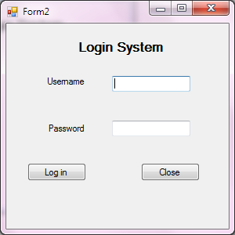

You need to enter the correct login details before you are able to access the main menu which is the library database. If you do not enter both the username and password on the textbox correct an error message will appear. Click ‘try again’ and make sure you enter the valid details.

Once you are logged in you (librarian) can do anything with the information related to members and library materials such as books and films. You can also add and delete data from the system if necessary.